**Study Guide For EOC Part 1 !!**

**DNA**

* **DNA**- **Deoxyribonucleic acid**. This is what makes you, you! It is located in the nucleus of every cell in your body.
* It is a nucleic acid which means it is made of **nucleotides**.

A nucleotide is made of three things- a phosphate, sugar, and a base.

* The sugar in DNA is **deoxyribose** (look at its name).

There are 4 bases- **Adenine**, **Thymine**, **Guanine,** and **Cytosine**.

A goes with T G goes with C

* The bonds that connect the bases are called **hydrogen bonds** which are weak so the DNA can unzip. The strong bonds which connect the sugars and the phosphates are **covalent bonds**.
* **Watson and Crick** discovered the shape of DNA which is a **double helix**.

**Hydrogen Bond**

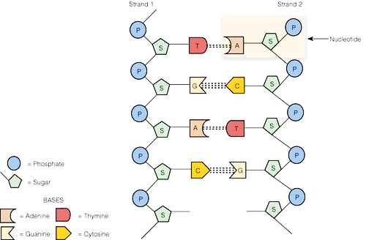

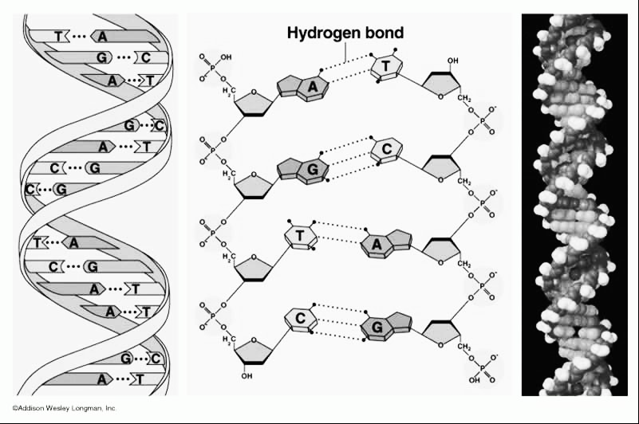

**Covalent bond**

**DNA replication** is how we make more DNA. It happens during the **“S” or Synthesis phase** of interphase. DNA has to be replicated before your body can make new cells or **before cells divide**. This happens in the nucleus. DNA is **semi-conservative** because the new strand of DNA have one strand from the “old” DNA and one “new” or complementary strand of DNA.

The DNA unzips down the middle by breaking the hydrogen bonds and then bases come and match up. The new matching strand is called the **complementary strand**. This makes two identical strands of DNA.

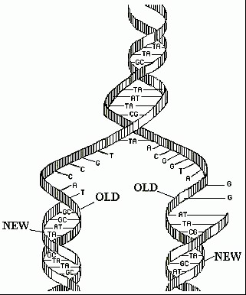

* You should be able to match up DNA during replication like below: If DNA is **AGCTTACTTGG**

The **complementary strand** would be **TCGAATGAACC**

* **Mutations**- Sometimes when DNA is replicating there are mistakes called mutations. Mutations **can be good or harmful**. They **cause variations** and are passed on to offspring if they occur in the gametes. Mutations can be random and spontaneous or caused by **exposure to a chemical or radiation**. **Can occur DNA or RNA and during Mitosis or Meiosis**.
* **Addition or insertion mutations**: adding a base to the DNA strand
* **Deletion mutation**: deleting a base from the DNA strand
* **Point mutations**: Changing one base to another. For instance changing a “G” to a “T”.

**RNA**

* **RNA**- Ribonucleic acid- used to make proteins
* This is another type of **nucleic acid**. It is also **made of nucleotides**.

The sugar is **ribose**.

It is single stranded and has **Uracil** instead of Thymine.

So U goes with A G goes with C

* **mRNA is made in the nucleus from DNA** and the process is called **Transcription**.
* Be able to match up the correct RNA with the DNA like below:

DNA Strand: AGCTTCTTAGGC

RNA Strand: UCGAAGAAUCCG

* There are three types of RNA:

**mRNA**- messenger RNA—it takes the **message from the DNA** to the ribosome

**tRNA**- transfer RNA- it **bring the amino acids** to the ribosome

**rRNA**- ribosomal RNA- this makes up the ribosome, factory where proteins made

**Codon**- every three bases on an mRNA strand. Used to find the amino acid.

**Anticodon**- three bases on the tRNA

**Translation**- when the cell **makes a protein** from RNA. **Happens in the ribosome**



**Amino Acid**

**tRNA**

**Ribosome**

**mRNA**

* In order to find out what amino acid will match up we must use the amino acid chart. We look at the codons on the mRNA to find out the amino acid.

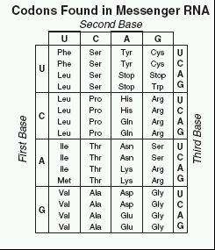

Ex. If mRNA codon is CCG then the amino acid from the chart is Pro

If DNA is TGA then the mRNA is ACU and the amnion acid is Thr

**Trait or Phenotype**

**Translation (ribosome)**

**Transcription (Nucleus)**

**DNA**

**Protein**

**RNA**

* If a **mutation occurs in the DNA or RNA then the protein will change which will result** **in a different phenotype**.







**Genetics**

* **Gregor Mendel** is considered the father of genetics. He worked with Pea plants to discover the basic concepts of genetics.
* Two important Laws that Mendel developed:

**The law of independent assortment**- this law states that the alleles for each of our traits are inherited separately. Or the genes get shuffled. Example brown hair does not have to be inherited with brown eyes.

**The law of segregation**- this states that our alleles for a trait are separated when our sex cells are formed (meiosis)

* **Alleles**- different versions of a gene for a trait. Example either Tall (T) or short (t)

**Dominant**- the trait that **takes over** or covers up the recessive. (T)

**Recessive**- a trait that **gets covered up** (t)

**Heterozygous** or **Hybrid**- when a person has two different alleles, Tt. **Always dominant**.

**Homozygous** or **Pure**- when a person has two of the same alleles, TT or tt.

TT and Tt will show the dominant trait tt will show the recessive trait (all small!)

**Genotype**- the alleles or **letters** a person has (TT, Tt, tt)

**Phenotype**- the physical **trait** a person has ex. Tall or short

* **P** generation= parent **F1**- kids **F2**- grandkids
* **Simple Mendelian Inheritance:**

Blue is dominant to yellow. A hybrid blue is mated with a yellow.

Tall is Dominant to short.

If a Heterozygous Tall plant is mated with a Pure Tall plant.

B

b

b

b

B

b

B

b

b

b

b

b

Phenotype

50% blue

50% yellow

Genotype

Bb 50%

Bb 50%

T

T

Phenotype:

100% Tall

Genotype:

TT 50%

Tt 50%

T

T

T

T

T

t

T

T

t

t

* **Incomplete Dominance**: this is when both alleles are dominant. (use two big letters). There are three phenotypes. This is where two traits **mix or blend together an in-between trait**.

Red (RR) X white (WW) = Pink (RW)

* **Codominance**: this is when both alleles are dominant. (use two big letters). There are three phenotypes. This is where **BOTH traits show up**.

Red (RR) X white (WW) = **Roan** Cow or Red and white (RW)

**Sickle Cell Anemia** is an example of a **codominant** disease. It is more common in African

Americans. It protects someone from **malaria**. It can cause severe pain. The blood cells are sickle shaped.



You can be **Normal (NN)**, **a carrier or Sickle Trait (NS)** or have **Sickle cell anemia (SS)**. If you are a

Carrier/Sickle Trait you have both normal and sickle blood cells.

If a person who is a carrier or sickle trait and a person who has sickle cell anemia mated

50% would be carriers/sickle trait (NS)

50% would have sickle cell anemia (SS)



**Cystic Fibrosis**- it is a disease that is **autosomal** **recessive** disease (not- sex linked) and is characterized

by the person having a thick mucus in the lungs and digestive track. So since the disease is recessive having CF is rr and being normal is then dominant.



A man is a carrier and his wife has cystic fibrosis

50% of the children normal

50% have the disease

**Huntington’s disease**- The person has nerve damage and results in death. It is **autosomal dominant**. Since the disease is dominant that means normal is recessive and hh.



A man is normal and his wife is homozygous for Huntington’s.

100% of the children have the disease

* **Multiple Alleles**- this is when you have more than two alleles. An example is blood type.

There are four blood types:

A- AA or Ai

You may also see it with the I’s. Remember IA is the same thing as A and IB is the same thing as B.

B- BB or Bi

AB- AB

O- ii

O is the recessive blood type and AB is the codominant blood type. The A and B

represent antigens or sugars on the blood cell.

Diana has blood type AB. Her husband Quentin has blood type A. His parents were A and O.

Their children could be:

25% AB 50% A 25% B

Lori has blood type O. Her husband Bobby has blood type B. His parents were both AB.

Their children could be:

100% B





* **Polygenic Inheritance**- these are traits that are controlled by many genes. It results in a variety of traits. Ex. hair and skin color and height.
* **Sex-linked or X-linked-** Sex in on the X! **Girls- XX** **Boys- XY**

Sex-linked traits are **on the X chromosome**. NOT on the Y. When working a punnett square make sure to use the X’s and Y’s ONLY if it mentions that its sex-linked. Sex-linked diseases are more common in males because they only have 1 X.

**Hemophilia** is a sex-linked recessive disease. It is when someone’s blood does not clot and they keep bleeding even from small cuts.

**Red-green colorblindness** is a sex-linked recessive disease. A person cannot tell the difference between red and green.

Colorblindness is sex linked recessive. Holly is a carrier and her husband is colorblind.

Hemophilia is sex linked recessive. Heather has hemophilia and her husband is normal





**2/4**, 50% of the children are colorblind

**1/2,** 50% of the girls are colorblind

**1/2**, 50% of the boys are colorblind

**2/4**, 50% of the children will have hemophilia

**0%** of the girls have hemophilia

**2/2**, 100% of the boys have hemophilia

* **Genetics, Environment, or Both:**

Remember traits can be entirely based on genetics entirely based on environment, or both. You could have these diseases in your DNA OR you could live in a way that causes you to get these diseases.

**Ask yourself what caused the person to get the disease or trait?**

-Was it in their DNA or evidence it ran in their family? Then **caused by genes**

-Was it caused by how they lived their life, where they lived, or a change in environment? **Then caused by environment**

-Was it is their family/DNA and also influenced by how they lived? Then **both genes and environ**

Examples: Down syndrome or Cystic fibrosis is purely based on genes

Rabbits changing color based on the weather or people going into the sun or smoking cause traits based on environment.

There are some diseases that are caused by your genes but **also** by your environment like **Diabetes, Asthma, Heart or Cardiovascular disease, Cancer, or PKU**.

**Pedigrees**

A pedigree is a family tree to show how a family inherits their trait.

A is a girl. A is a man. If it is colored in then they have the trait or disease.

If the trait is in every generation then it is a dominant trait

**If the trait is in only a few people and it’s in boys and girls than it is recessive**.

**If it’s in only a few people and they are mostly boys then it is sex-linked recessive**



Autosomal Recessive



Sex linked recessive

* Remember that if the parents are normal and the child has the disease then the parents must be heterozygous.

**Biotechnology**

* **Human Genome Project**- a project that decoded all of the 3 billion bases (AGCT’s) in our human DNA. The purpose of this was to help us locate genetic diseases in our DNA and to perhaps one day find a cure using gene therapy. It could also result in designer babies.
* **DNA Identification or Gel Electrophoresis or DNA fingerprinting**:

This is when we cut up our DNA using **restriction enzymes** and run it through a gel to get a band

pattern of DNA. On the gel the **short pieces of DNA are at the bottom** of the gel and the **long**

**pieces of DNA are at the top** of the gel. Purpose is to sort DNA fragments by length.



This can be used to find a criminal-

DNA bands must match **EXACTLY**.

Suspect B did it

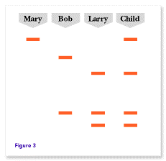

This can also be done to find relatives-

the closer the patterns the closer the relative

This can be used to find the parents of a child-

the child cannot not have any bands that it didn’t

get from mom or dad.

Larry you are the Father!

* **Cloning**- making an identical individual (remember mimi the mouse)

When a nucleus of a body cell (somatic) is placed into an egg.

This allows scientists to make **identical genetic copies** of an organism quickly.

The first clone was **Dolly**, a sheep. Its **Asexual** Reproduction.

It could allow us to **bring back extinct or endangered organisms**

The cloned organism wouldn’t be exactly the same due to environment.

* **Transgenic organisms**:

They have DNA from another organism in their DNA.

Also known as **GMO’s** or **Genetically Modified Organisms**,

Cut out the DNA from one organism with **restriction enzymes** and put it into another organism’s DNA. This is **genetic engineering**.

**Bacterial Transformation or transgenic GMO bacteria:**

-**Human DNA is cut out with restriction enzymes and then put into a** **bacterial plasmid (circular DNA)** and then put into the bacteria

New organism has **recombinant DNA** since it has been recombined

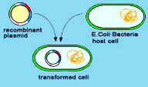

Human DNA has been put into **Cows and Bacteria** so that they both now make

**insulin.** Bacteria have also been **engineered to eat oil** and mosquitoes to stop Zika.

This could be dangerous because it could result in a loss of biodiversity, could **create a**

**new and dangerous disease**, or could cause allergic reactions to the pesticides now in

our crops.

* **Gene Therapy**- replacing “diseased” DNA in a person (remember the aliens)

By using a virus vector**,** pieces of “good” DNA is used to **replace a piece of “bad” DNA** to **cure someone of a genetic disease**. They are trying to cure cystic fibrosis but haven’t yet. **SCID** (**severe combined immune deficiency disorder**), bubble boy, has been cured using gene therapy.

* **Stem Cells**- these are cells that **can become any type of cell** in the body. They do not yet have a job- **undifferentiated**. This could **help cure diseases** but are controversial because they **come from embryos**. Can also be found in adults or cloned.
* All cells have the same DNA and genes. However, **genes are activated or turned on and off in cells** to specialize them or determine their job. This is called **differentiation.** For instance a muscle cell will have different genes activated than a blood cell. Chemical signals are released to control gene activation. Once a cell is differentiated it cannot be changed.
* **Stem cells are in embryos (baby)**.They can also be found in adults like in the bone marrow.

**Specialized Cells:**

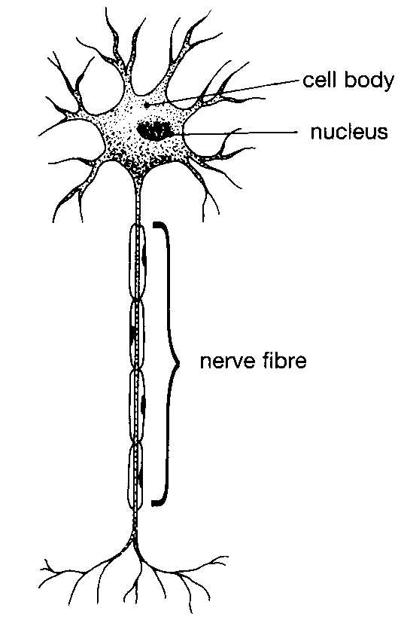

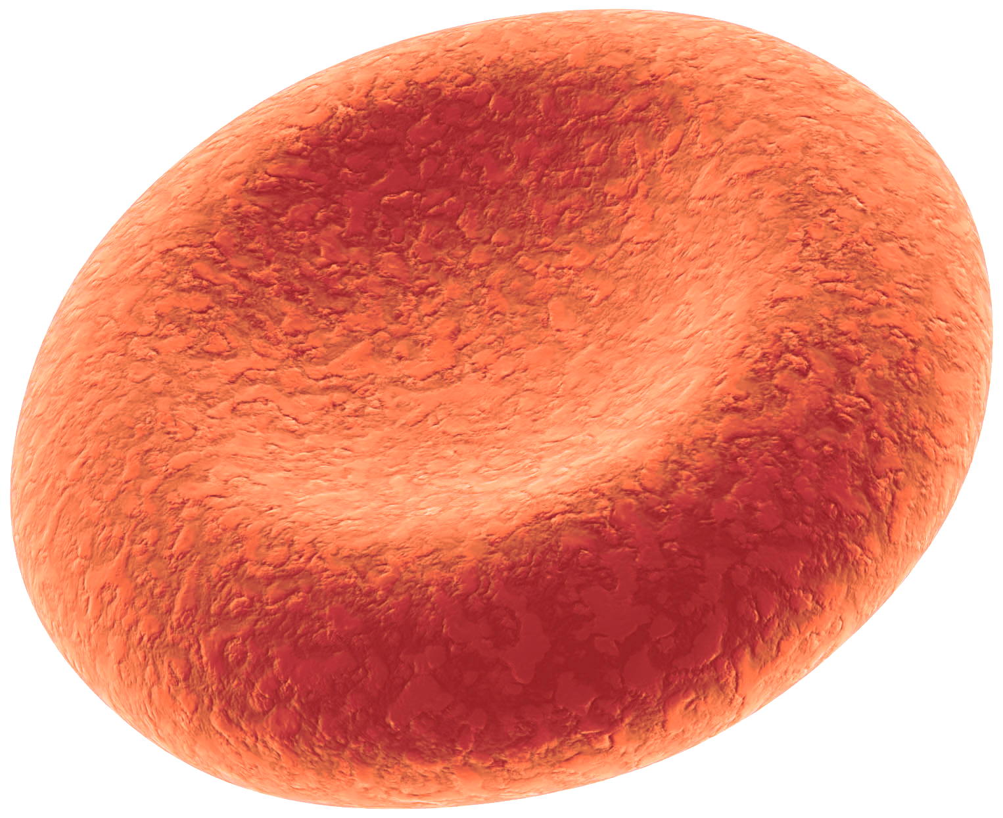

A **blood cell** is flat and small so it can move easily through the vessels.

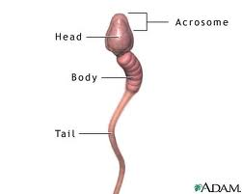

A **nerve cell or neuron** is long and thin to pass information signals to the next cell.

The **sperm**’s tail allows it to travel to the egg and enzymes in the head allow it to enter the egg.

**Muscle cells** contain fibers which allow the cells to move by shortening or contracting.

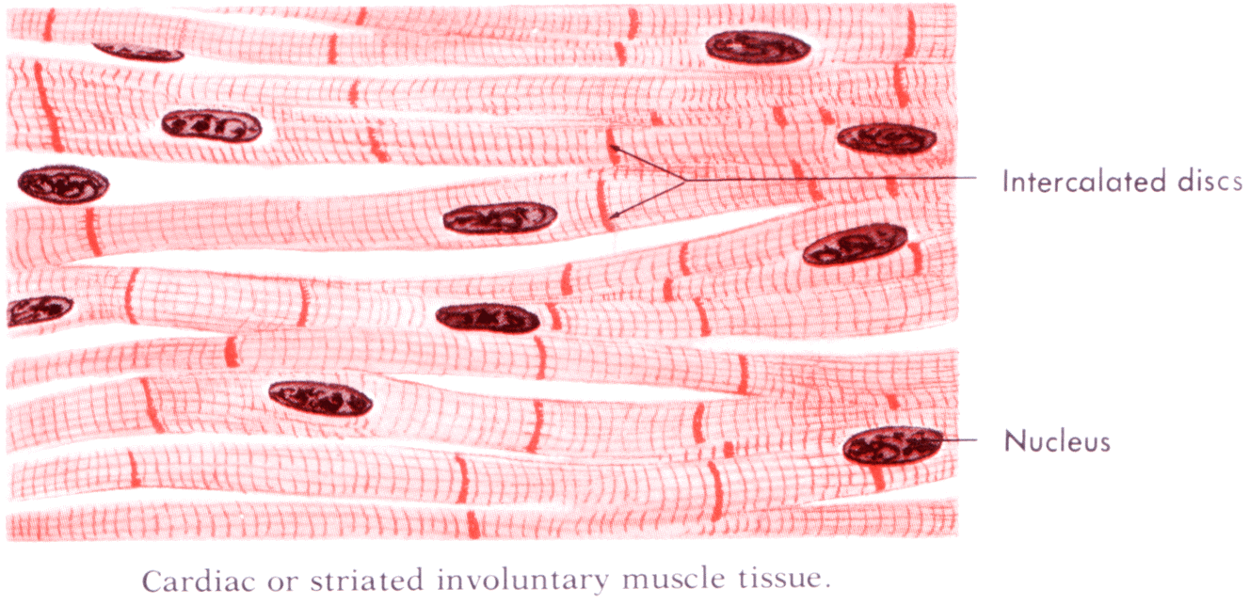

**Mitosis and Meiosis**

Our bodies **need to make more cells for repair and growth**- there are two types of cells and two types processes that our bodies do.

|  |  |
| --- | --- |
| **Mitosis** | **Meiosis** |
| “toes”= makes body cells/ **somatic** cells | Me=Se This makes sex cells/ **gametes** |
| Makes **2** cells | Makes **4** cells |
| ALL of their chromosomes, 2 sets, **2n** = **Diploid** Cells, in **pairs** | have ½ of chromosomes, 1 set, **1n** = **haploid** |
| Makes **identical cells** or **clones** | makes different cells or **variation** |
| **Asexual** reproduction | **sexual** reproduction |

* If a cat has a body cell of 80 chromosomes than they sperm will have? 40
* If an egg of a fish has 100 chromosomes then the tail would have? 200

The **Cell Cycle** is a process where cells **grow**, make **copies of chromosomes**, and **divide** to make new cells.

In **Interphase** the cell is living its life. **Happens before Mitosis or Meiosis. Longest part of cell life.** There are three parts of Interphase:

Growth 1 (**G1**): The **cell grows** and doubles organelles

**Synthesis (S):** More DNA is made by **DNA replication**

Growth 2 (**G2**): The cell continues to grow getting ready to divide

Then the cell will divide in two through **Mitosis** or the M phase.

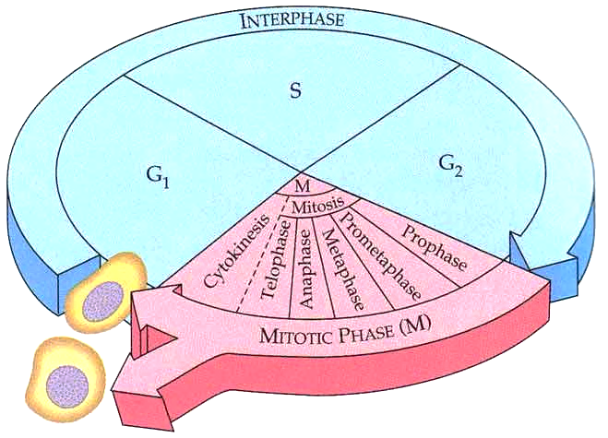

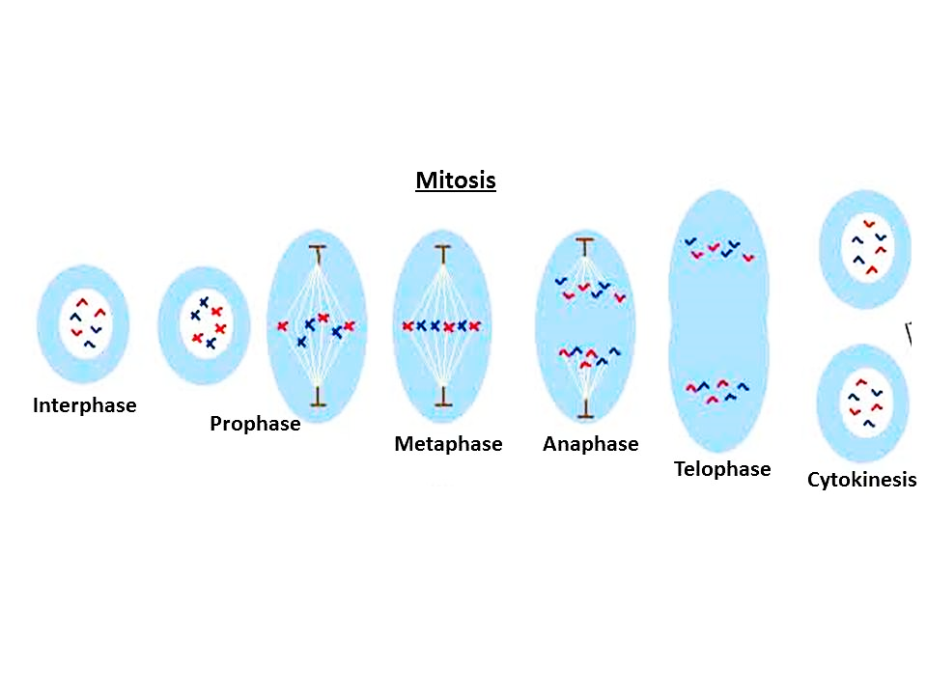

Start

Makes **2 body cells with the same** chromosomes as the parent

\***Bacteria and protists** reproduce asexually through **mitosis** where they divide in two called **BINARY FISON**

*Sometimes a mutation in the DNA leads to out of control mitosis divisions. This uncontrolled mitosis results in **cancer**.

\***Both Mitosis and Meiosis can have Mutations**.

**Meiosis** is the processes where **sex cells/gametes (egg and sperm)** are made.

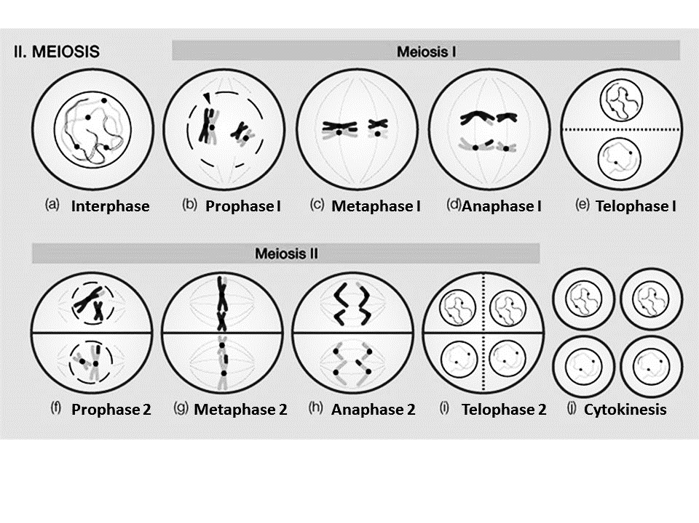

Ends with **4 cells with half the number of chromosomes** and a unique combination

* In Meiosis the arms of the chromosome will trade pieces- this **provides variety** and is called **crossing over.** During Meiosis the genes are “shuffled” called **Independent Assortment** which also creates **variation**.
* **Homologous chromosomes** are chromosomes that code for the same trait. They **pair up** in meiosis during metaphase 1 before splitting apart. **Mitosis has pairs of homologous chromosomes in the final cell “2n”.** BUT **meiosis does not have pairs so only has “n” chromosomes at the end (half).**
* When a sperm and Egg come together this is **fertilization** and forms a **zygote** (baby).
* The Human diploid number is **46** and the haploid number in our egg and sperm is **23**.
* Sometimes in Meiosis the chromosomes fail to separate called **Nondisjunction**

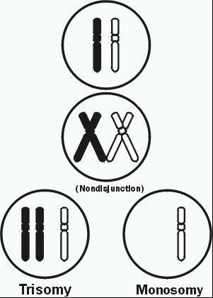

which results in the baby having too many or too few chromosomes.

* **Karyotype** is a picture of someone’s chromosomes and is used to identify

genetic diseases caused by nondisjunction.

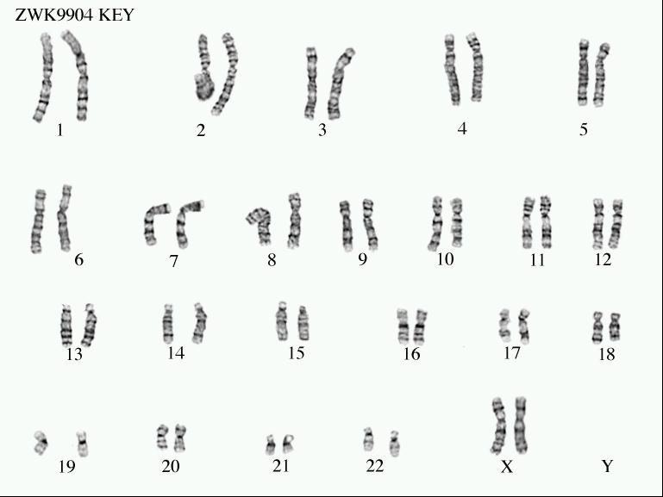

girl

* An **Amniocentesis** is when you take fluid from a pregnant woman and do a karyotype to determine if the unborn baby has a genetic disease

**Down’s Syndrome**- this is caused by **nondisjunction**.

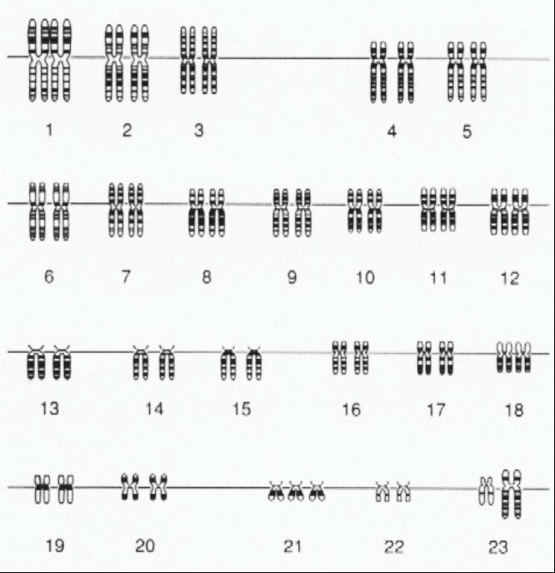

The person has **three 21 chromosomes** and so a total

of 47 chromosomes. It can also be called **trisomy 21**.

This person has a low IQ.

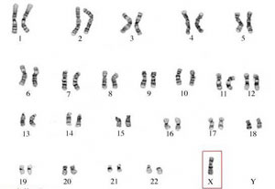

Boy

**Turner’s Syndrome**- This is a disease also caused by **nondisjunction**. It is

when a girl is **missing an X** so she only has 45 chromosomes. It is often

represented by XO

**Evolution and Classification**

* **Spontaneous generation or Abiogenesis:** life suddenly appears from nonliving things
* **Biogenesis:** Life beginning from life
* **How did life evolve on earth?**

Early earth- **no oxygen**, volcanoes, oceans, no life

**Miller and Urey**-They mixed gases and water together and zapped it with an electrode.

This did not produce life BUT it did produce some of the **organic molecules** like amino acid and

nucleic acids that are necessary for life.

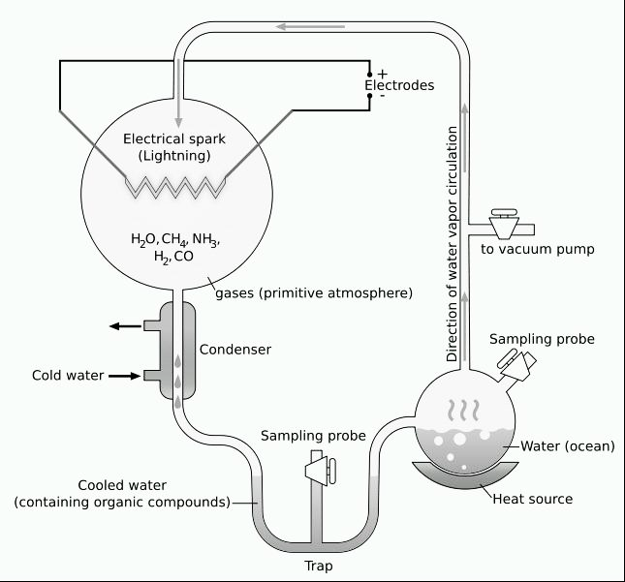

* **Early Life Theory**:

1. macromolecules organized into **protocells**
2. Protocells become **1st living organism**: **prokaryote bacteria** which are **heterotrophs (eats) and anaerobic**

**(no oxygen)**

1. Prokaryotes are running out of food so **next come: photosynthesizing autotroph prokaryotes**

**(make own food)**

1. Autotrophs make **oxygen** which in turn build the **ozone layer**
2. This ozone allows for other more complicated organisms to evolve

* **Endosymbiosis**- “inside relationship”

**Theory that Eukaryotes came from Prokaryotes**. Some **prokaryotes ate** other prokaryotes

but instead of dying these eaten prokaryotes developed a **mutualistic relationship** with the

prokaryote that ate them. They became organelles. AND now that the prokaryotes had organelles

they are **Eukaryotes**.

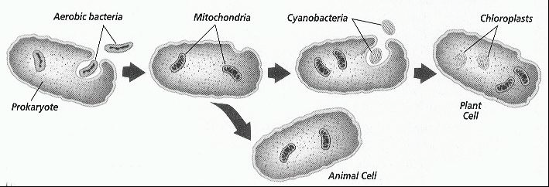

* After Eukaryotes evolved **multicellular organisms** appeared.

**Natural Selection**- “survival of the **fittest**” But really it is that the organism who

has the **best adaptation** or **favorable trait** can **reproduce** and pass on its genes and traits. Competition

for resources means the organism **best adapted to their environment survives**. **Adaptations are caused**

**by mutations in the genes and sexual reproduction and cannot be learned.**

Darwin developed this theory when he traveled to the **Galapagos islands**. He studied **finches** and was able to see that perhaps they had a **common ancestor**. **Adaption to different environments** resulted in different beaks and species over time.

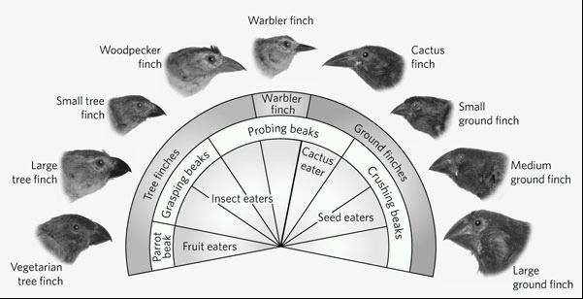

Darwin was able to show that **either a species will adapt to its environment or it will die**. And that the organism with the best adaptation will reproduce the most to pass this adaptation on to future generations. **Camouflage** is a great adaptation because it allows the organism to blend into their environment and survive.

* Due to natural selection our pests are becoming **resistant to pesticides** and our bacteria are becoming **resistant to antibiotics** (medicines). **Only the weak ones were killed off which left the resistant ones to reproduce** which is now all we have. **Resistance is caused by a mutation in the genes. NOT caused by the antibiotic or eating the pesticide. Caused by MUTATION and BEST ADAPTED SURVIVIES.**

**Immune System**

* **Antibodies**: proteins in our body which identify and help remove viruses and bacteria from our body
* **Memory B cells**- your body remembers every virus you have ever had. When you get the same virus again the memory cell will recognize it and order an attack before you can get sick.
* **Vaccine**- this is when you are given a weakened or dead virus. This allows your body to “remember” a virus that never actually made you sick. It prevents you from ever getting truly sick.
* **Antibiotic**- this is a medicine which will kill bacteria
* **Antiviral**: drugs that help fight off a viral infection
* **Active immunity**- **You make** antibodies. This is immunity or resistance that a person has because they have actually **had the disease**. You can also get this from a **vaccine**. Ex. You have had chicken pox so now you have active immunity against it or you get a vaccine against chicken pox.
* **Passive immunity**- **You are given** antibodies. This is when you are immune from a virus that you never actually had. **Mothers** can pass this on to their children when they breastfeed them or you can be **given** the antibodies.

**How do new species evolve?**

Sometimes a part of a species is separated from the rest of the group either by a highway, mountains, ocean, or any other physical barrier. This is called **geographic isolation**.

Once they have been separated for a long time each group will change with their environment—natural selection.

* This will result in them being so different that even if they were to come back together again they could not mate. This is called **reproductive isolations**. This can be because their bodies no long match up or perhaps their social behaviors are now different (mating seasons or mating rituals). **If you can mate you are the same species.**
* **When the two can no longer mate they are now two different species** and this creation of a new species is called **Speciation**. (remember the mice on the video and the M&Ms)
* There are several different “proofs” for evolution:

**Fossils**- show how organisms changed through time and can show relationships or what organisms have gone extinct.

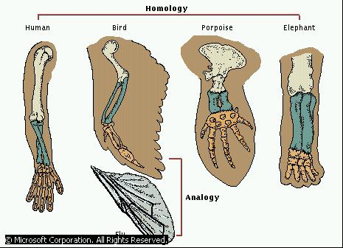

**Anatomical-** by comparing the anatomy

or body structure of organisms we

can determine how closely related they are.

Human, bird, and porpoise are more closely related to each other than the fly. You can tell because their body structure is similar or **homologous**.

* **Biochemical similarities**- by **comparing the DNA or the Amino Acids in protein** we can determine how closely related organisms are. They closer their DNA and proteins are they closer related they are.

All of this evidence can point to a **common ancestor** if they are all similar. The **ancestor** is the original organism that everything else came from.

**Genetic Drift**: the **change of the genes in a population** is more **likely to happen in a small population**

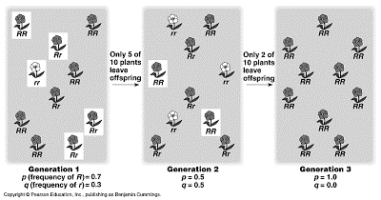

**Phylogenetic trees**- a diagram showing branching of organisms from a common ancestor.

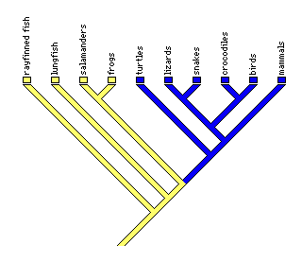

The **closer they are together on the map the closer related they are**. **If they are on the same branch they are closer related.**

The oldest species branched off first.

Salamanders and frogs would be more closely related than lungfish and frogs.

Ancestor (oldest)

**Classification**

* First classification system was developed by **Aristotle**, but it had a few problems. **Based on physical characteristics.**
* The modern day classification that we use today was developed by **Carolus Linnaeus. At first there were two kingdoms (animals and plants)**, then five and now 6. We now have more kingdoms because we have **improvements in technology**.
* The **six kingdoms** are: plant, animal, protist, fungi, eubacteria, archaebacterial.

**Linnaeus classified organisms on their body structure and on many different characteristics**.

* **There are 8 levels of classification**

Domain



Did Domain

King Kingdom

Philip Phylum

Come Class

Over Order

For Family

Good Genus

Spaghetti Species

* **The largest and most general or broad classification would be the Domain and Kingdom**.
* The smallest and most specific classification is the species. Organisms can only **interbreed** if they are in the same species.
* **Dichotomous Key**—this is like scavenger hunt to find out the scientific name of an organisms

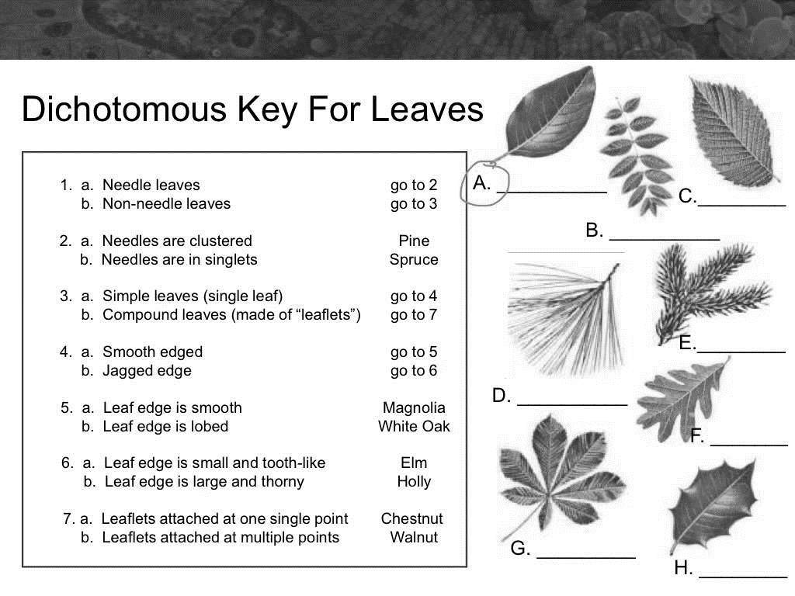

Leaflets are little leaves and lobes are like fingers on the leaf.

**Can you figure out the names of the leaves?**

What is the name of leaf B? Walnut

What is the name of leaf H? Holly

What is the name of leaf F? White Oak