Study Guide: Biochemistry

- A Macromolecule or polymer is a large molecule. If a molecule had carbon than it is considered an Organic molecule.

- There are four main macromolecules that are important to biology:
carbohydrates, lipids, proteins, and nucleic acids

Carbohydrates- these are sugars used for quick energy. Their building blocks or monomers are monosaccharides. Remember many sugars end in -ose

Elements made of Carbon, Hydrogen and Oxygen in a 1:2:1 ratio.

Types:

Monosaccharides---- one sugar----examples Glucose which is made in photosynthesis
Fructose which is in honey and fruit
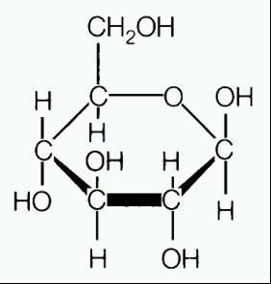

Glucose

Disaccharides--2 sugars or 2 monosaccharides connected---
Example sucrose which is table sugar

Polysaccharides---many sugars- examples Cellulose which is in cell walls
Starch which is used for plant energy storage
Glycogen which is used for animal energy
storage in the liver

Lipids- these are fats, waxes and oils. They are used for long term energy storage and for the cell membrane. Also used for insulation to protect animals from the cold.

These are made of long chains of carbon and hydrogen and a little bit of oxygen.

Triglyceride- is a fat made of a glycerol backbone and three fatty acid chains.
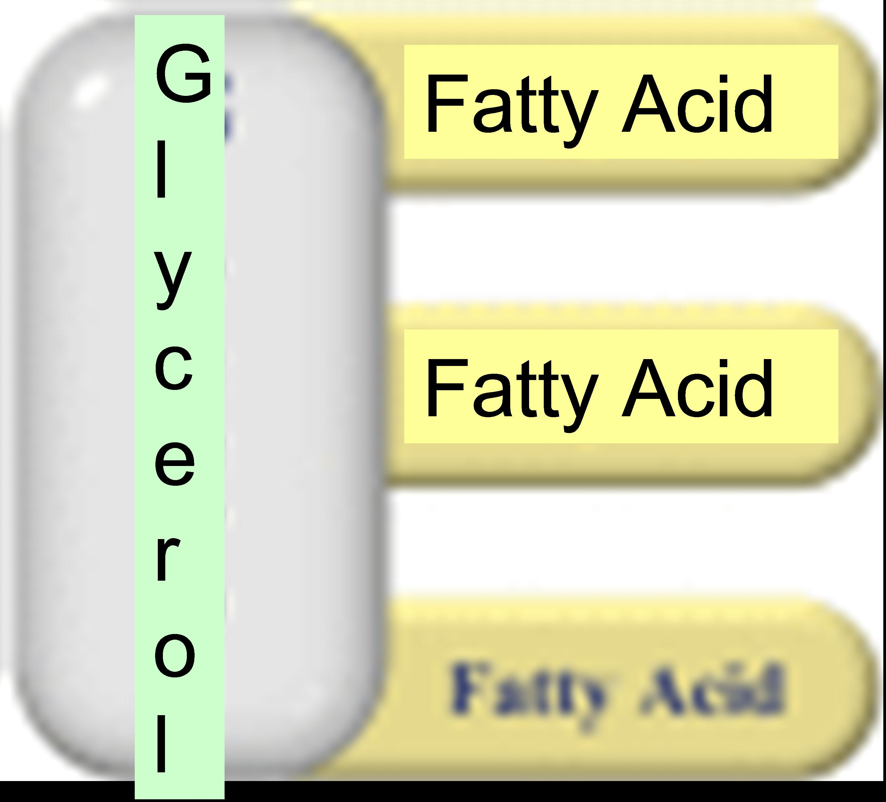
Phospholipids: fats that make up the cell membrane
Steroids: fats which are in rings instead of chains like cholesterol

Examples of lipids:
Proteins- Made from amino acids which are held together by peptide bonds. There are 20 amino acids. They are made in the ribosome. Proteins fold in a 3D shape and this shape determines their function.

Important Proteins:

Enzymes (see enzymes in this packet)

Hemoglobin- a protein in a blood cell that helps carry oxygen in the blood.

Insulin- a protein in the body which helps maintain proper blood sugar levels. If there are problems making insulin than a person could have diabetes.

Nucleic Acids:

These molecules are our inherited genetic information.
The two main examples are RNA and DNA
They are made of Nucleotides. Nucleotides are made of a phosphate, sugar, and base.
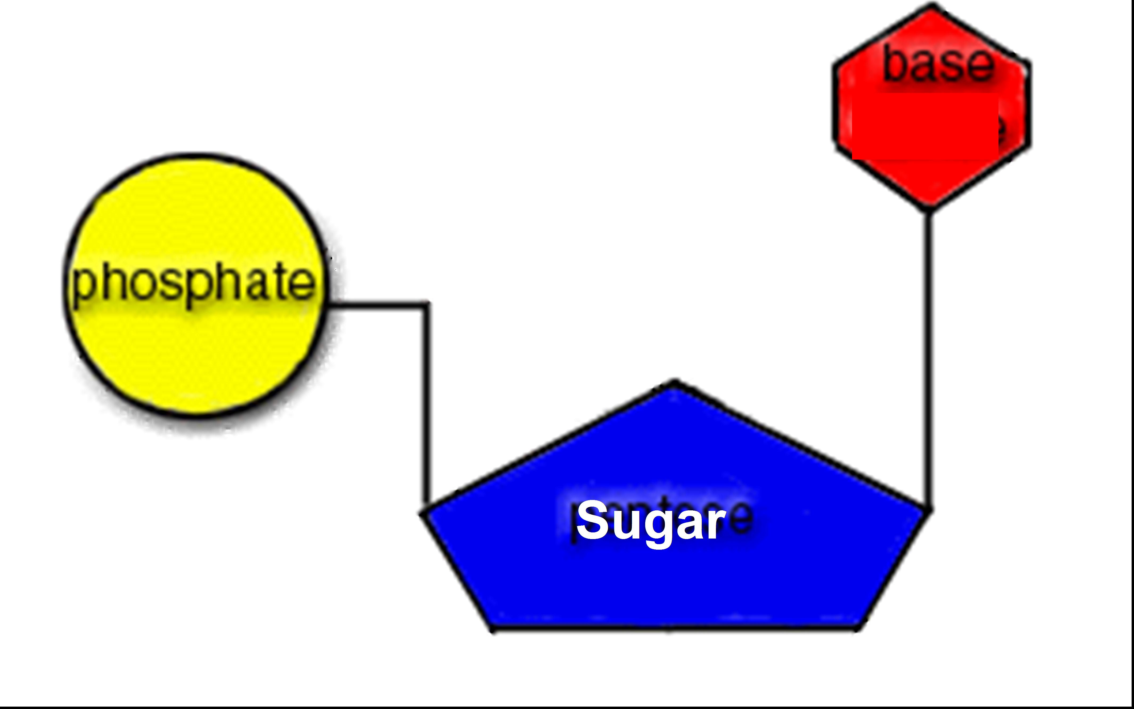

Enzymes

- Enzymes can also be called Catalysts. Several enzymes end with –ase.
Ex. Lactase, Maltase. They can be used over and over again.

- These are proteins that help speed up reactions. Without them most of the reactions that happen in our body would happen so slowly that we would die. They are reusable.

- People who lack the enzyme Lactase are Lactose intolerant. Meaning they cannot break down the sugar, lactose, in dairy products. So if they were to drink milk they would have an upset stomach.

- Every reaction needs a certain amount of energy to start (activation energy). Enzymes lower the amount of reaction energy needed. So since the reaction doesn’t need as much energy it can go faster.
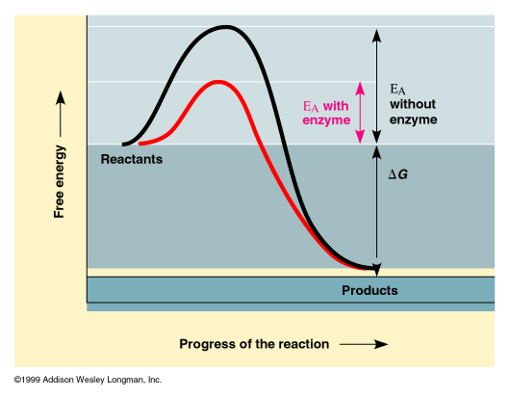

- Enzymes fit together with substrates. Substrates are whatever chemical the enzyme is working on. They fit like a lock and key. Enzymes only fit their specific substrate.

- The place where the substrate fits into the enzyme is called the active site.
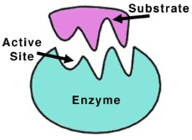

- If you change the shape of the enzyme it won’t work anymore. You can do this by changes in temperature or pH level. Its called denaturation.
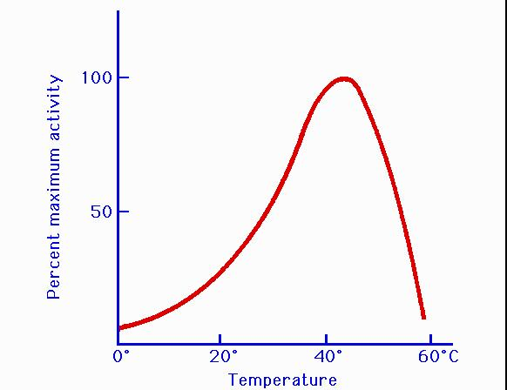
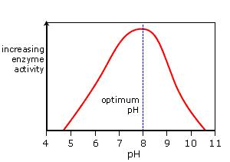

*Remember the words optimum and optimal mean best or highest!

Acids and Bases

pH is a measurement of how acidic or basic a solution is.

Less than 7 is an acid
Strong acids and bases can be dangerous
7 is neutral
More than 7 is a base

Buffer: Is a chemical which will resist (stabilize) pH change or will keep pH from changing even if an acid or base is added to solution.

Our bodies have buffers to ensure that the pH of our body does not become too acidic or basic but instead is around the neutral range. It helps us maintain Homeostasis.

