Study Guide Biotechnology

- Human Genome Project- a project that decoded all of the 3 billion bases (AGCT’s) in our human DNA. The purpose of this was to help us locate genetic diseases in our DNA and to perhaps one day find a cure through gene therapy. It could also result in designer babies.

- DNA Identification or Gel Electrophoresis:
This is when we cut up our DNA using restriction enzymes and run it through
a gel to get a band pattern of DNA. On the gel the short pieces of DNA are at
the bottom of the gel and the long pieces of DNA are at the top of the gel.
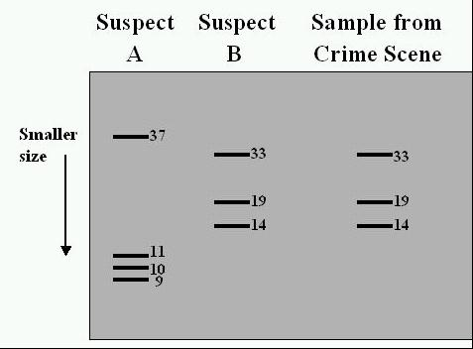
This can be used to find a criminal-
DNA bands must match EXACTLY.
Suspect B did it

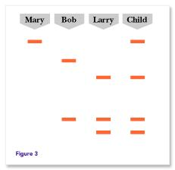
This can also be done to find relatives-
the closer the patterns the closer the relative

This can be used to find the parents of a child-
the child cannot not have any bands that didn’t
come from mom or dad.

Larry you are the Father!

- Genetic Engineering:
Transgenic organisms
Also known as GMO’s or Genetically Modified Organisms,
Cut out the DNA from one organism with restriction enzymes and put it
into another organism using a virus vector. They have recombinant DNA.
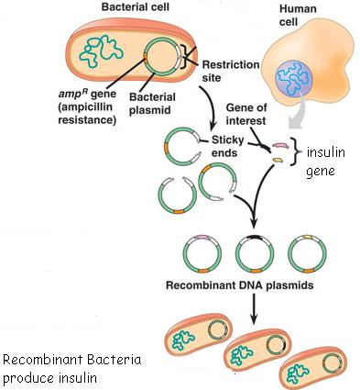
Bacterial Transformation:
-cut out human DNA using restriction enzymes and insert it into a bacterial plasmid
-get bacteria to take in the plasmid
-Now the bacteria can make human insulin

GMO’s and Bacterial transformation can be used to help people with diseases. They can also make better crops. However, they could be dangerous because it could result in a loss of biodiversity or create a new and dangerous disease.

- Cloning- making a genetically identical individual (remember mimi the mouse)

When a nucleus of a body cell is placed into an egg. Asexual Reproduction.
This allows scientists to make identical copies of an organism quickly.
The first clone was Dolly, a sheep.
It could allow us to bring back extinct or endangered organisms.

- Gene Therapy- replacing “diseased” DNA in a person (remember the aliens)
By using a virus vector pieces of “good” DNA replace diseased DNA to cure
someone of a genetic disease. In Severe Combined Immunodeficiency disorder
(SCID) a person does not have an immune system. Gene Therapy has been limitedly
successful in curing people of SCID.

Cell Differentiation:

- All cells have the same DNA and genes. However, genes are activated or turned on and off in cells to specialize them or determine their job. This is called differentiation. For instance a muscle cell will have different genes activated than a blood cell. Chemical signals are released to control gene activation. Once a cell is differentiated it cannot be changed.

Cells are specialized to perform particular functions. For instance:
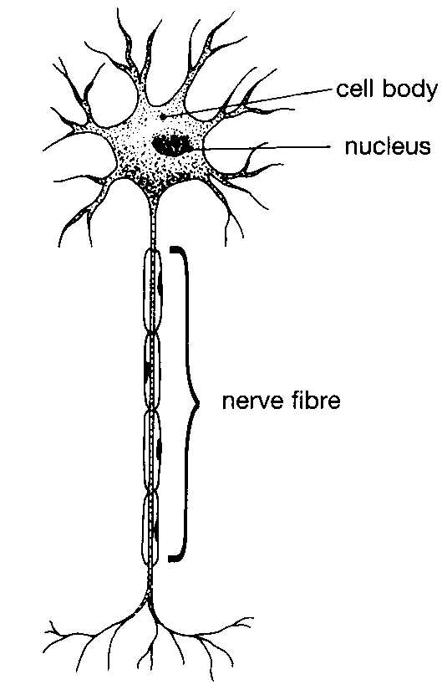
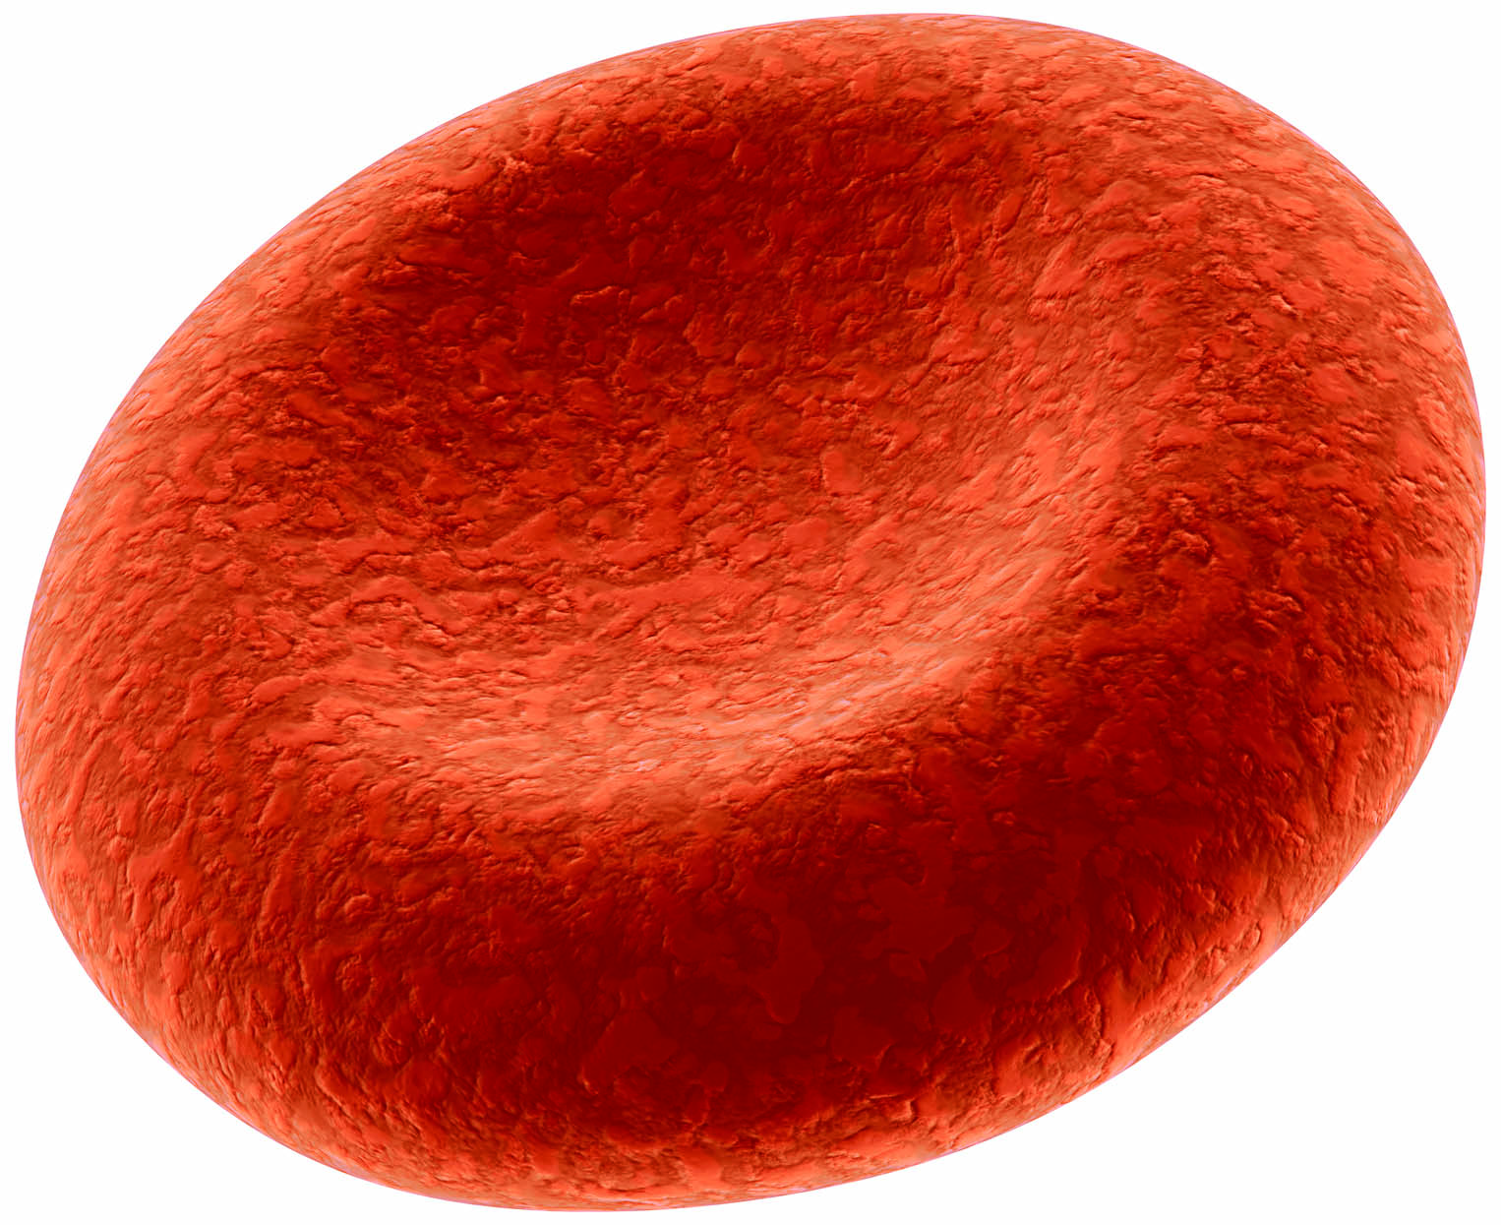

A blood cell is flat and small so it can move easily through the vessels.
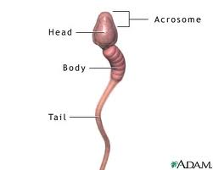
A nerve cell or neuron is long and thin to pass information signals to the next cell.

The sperm’s tail allows it to travel to the egg and enzymes in the head allow it to enter the egg.

Muscle cells contain fibers which allow the cells to move by shortening or contracting.
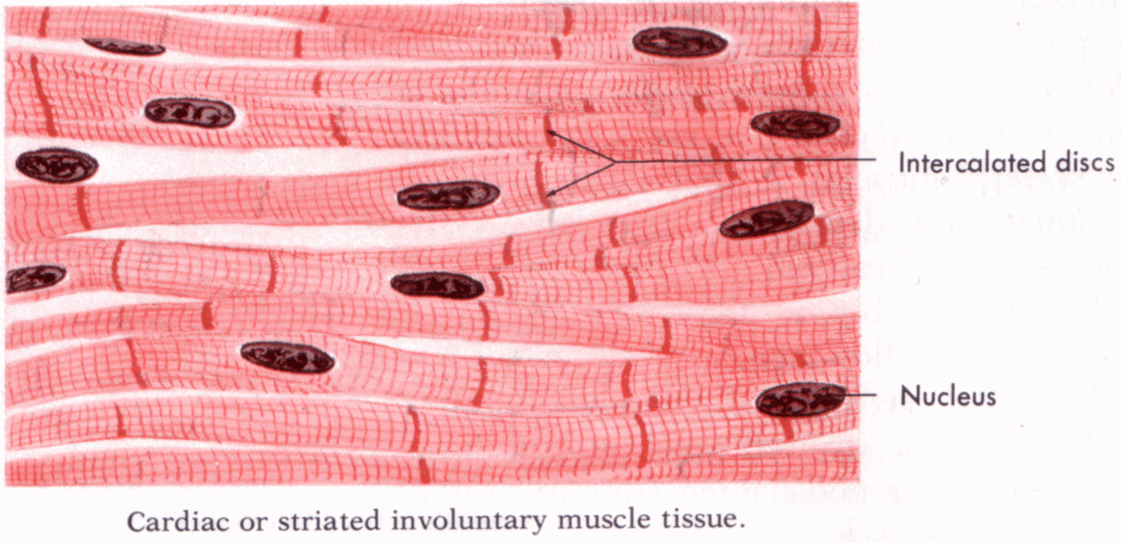

Stem cells are cells that are not specialized or do not have a job yet. They are undifferentiated. They can become any cell in the body.

Where can you find stem cells?
- Stem cells are in embryos (baby).
- They can also be found in adults like in the bone marrow.
- They can be made in the lab from Induced Pluripotent cells (IPS) or cloning.

Because stem cells have the potential to replace many cells in the body they could potentially cure many diseases. However, the use of embryonic stem cells is controversial since they result in a destroyed embryo.

