Study Guide: DNA, RNA, and Proteins

DNA
- DNA- Deoxyribonucleic acid. This is what makes you, you! It is located in the nucleus of every cell in your body.

- It is a nucleic acid which means it is made of nucleotides.
A nucleotide is made of three things- a phosphate, sugar, and a base.

- The sugar in DNA is deoxyribose (look at its name).
There are 4 bases- Adenine, Thymine, Guanine, and Cytosine.
A goes with T G goes with C

- The bonds that connect the bases are called hydrogen bonds which are weak so the DNA can unzip. The strong bonds which connect the sugars and the phosphates are covalent bonds.
- Watson and Crick discovered the shape of DNA which is a double helix.
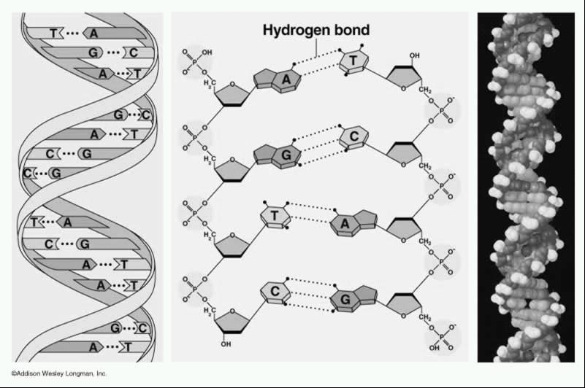

Covalent bond

DNA replication is how we make more DNA. It happens during the “S” or Synthesis phase of interphase. DNA has to be replicated before your body can make new cells or before cells divide. This happens in the nucleus. DNA is semi-conservative because the new strand of DNA have one strand from the “old” DNA and one “new” or complementary strand of DNA.

The DNA unzips down the middle by breaking the hydrogen bonds and then bases come and match up. The new matching strand is called the complementary strand. This makes two identical strands of DNA.
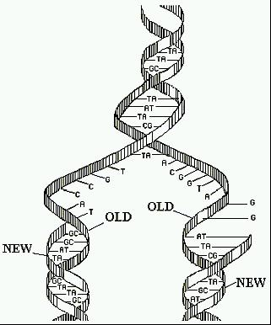

- You should be able to match up
DNA during replication like below:
If DNA is AGCTTACTTGG The complementary strand would be TCGAATGAACC
- DNA can come in different formats but it is all DNA.
Chromatin- this is how DNA spends most of its time. It is long stringy DNA
Chromosomes- this is when DNA coils up every tightly and becomes short and
thick. This happens when the cell needs to divide.
Gene- this is a segment of DNA that codes for a specific protein or trait
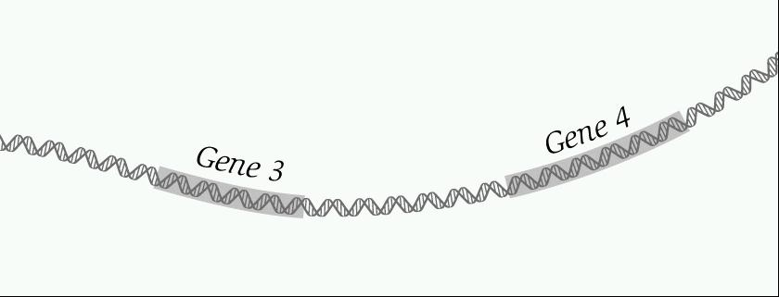

- Mutations- Sometimes when DNA is replicating there are mistakes called mutations. Mutations can be good or harmful. They cause variations and are passed on to offspring if they occur in the gametes. Mutations can be random and spontaneous or caused by exposure to a chemical or radiation.
- Addition or insertion mutations: adding a base to the DNA strand
- Deletion mutation: deleting a base from the DNA strand
- Point mutations: Changing one base to another. For instance changing a “G” to a “T”.

RNA

- RNA- Ribonucleic acid- used to make proteins

- This is another type of nucleic acid. It is also made of nucleotides.
The sugar is ribose.
It is single stranded and has Uracil instead of Thymine.
So U goes with A G goes with C
- mRNA is made in the nucleus from DNA and the process is called Transcription.

In transcription, DNA briefly unzips. The RNA nucleotides match up to form
mRNA. Then the mRNA leaves to go to the ribosome and the DNA zips back up.
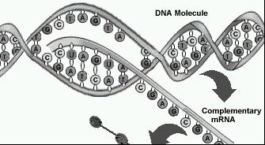

- Be able to match up the correct RNA with the DNA like below:

DNA Strand: AGCTTCTTAGGC
RNA Strand: UCGAAGAAUCCG

- There are three types of RNA:

mRNA- messenger RNA—it takes the message from the DNA to the ribosome
tRNA- transfer RNA- it bring the amino acids to the ribosome
rRNA- ribosomal RNA- this makes up the ribosome

Codon- every three bases on an mRNA strand. Used to find the amino acid.
Anticodon- three bases on the tRNA
The codon and anticodons will match up during translation.

Translation- when the cell makes a protein from RNA. Happens in the ribosome

- the mRNA hooks into the ribosome
- the tRNA brings in the amino acid- anticodon matches up with codon
- a peptide bond forms between the amino acids making a protein or polypeptide chain.
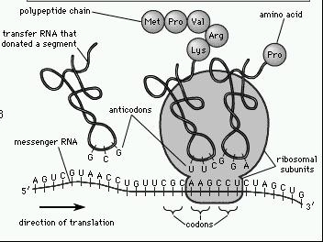

Ribosome
tRNA

mRNA

- In order to find out what amino acid will match up we must use the amino acid chart. We look at the codons on the mRNA to find out the amino acid.
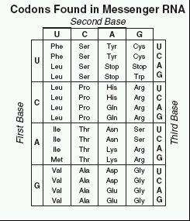

Ex. If mRNA codon is CCG then the amino acid from the chart is Pro
If DNA is TGA then the mRNA is ACU and the amnion acid is Thr
If the tRNA anticodon is AGU then the mRNA is UCA and the amino acid is Ser

Translation
Transcription
Trait or Phenotype
DNA
Protein
RNA

- If a mutation occurs in the DNA or RNA then the protein will change which will result in a different phenotype.

