**Study Guide :** **Evolution and Classification**

* **Spontaneous generation or Abiogenesis:** life suddenly appears from nonliving things
* **Biogenesis:** Life beginning from life
* **How did life evolve on earth?**

Early earth- no oxygen, volcanoes, oceans, no life

**Miller and Urey**-They mixed gases and water together and zapped it with an

electrode. This did not produce life BUT it did produce some of the

**organic molecules** like amino acid and nucleic acids that are necessary for life.

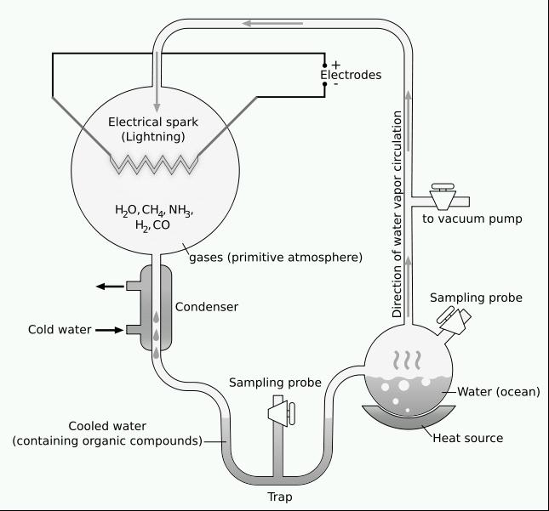

* **Early Life Theory**:

1. macromolecules organized into **protocells**
2. Protocells become **prokaryotes** which are **heterotrophs (eats) and anaerobic (no oxygen)**
3. Prokaryotes are running out of food so they become **photosynthesizing autotrophs (make own food)**
4. Autotrophs make **oxygen** which in turn builds the **ozone layer**
5. This ozone allows for other more complicated organisms to evolve

* **Endosymbiosis**- “inside relationship”

This is the theory that prokaryotes ate other prokaryotes but instead of dying

these eaten prokaryotes developed a mutualistic relationship with the

prokaryote that ate them. They became organelles. AND now that the

prokaryotes had organelles they are Eukaryotes.

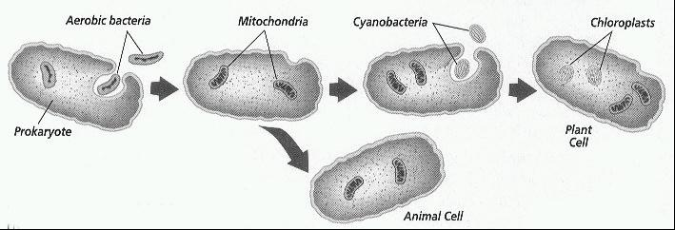

* After Eukaryotes evolved multicellular organisms appeared.
* **Charles Darwin**- often called the Father of Evolution.

He first came up with the idea that perhaps species change through time and

came from one common ancestor. He developed the idea of **Natural Selection**.

**Natural Selection**- “survival of the fittest” But really it is that the organism who

has the **favorable trait** can reproduce and pass on its genes and traits. Competition

for resources means the organism **best adapted to their environment survives**.

Darwin developed this theory when he traveled to the **Galapagos islands**. He studied **finches** and was able to see that perhaps they had a common ancestor. Adaption to different environments resulted in different beaks and species over time.

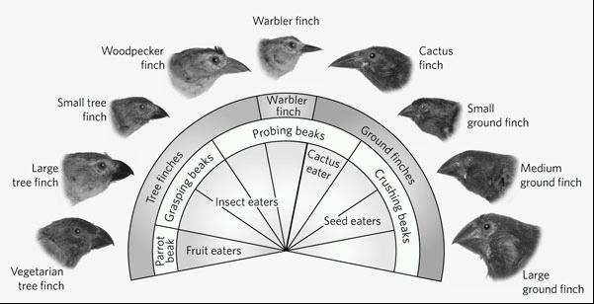

Darwin was able to show that either a species will adapt to its environment or it will die. And that the organism with the best adaptation will reproduce the most to pass this adaptation on to future generations.

* Due to natural selection our pests are becoming **resistant to pesticides** and our bacteria are becoming **resistant to antibiotics** (medicines). Only the weak ones were killed off which left the strong and resistant ones to reproduce which is now all we have.

**Immune System**

* **Antigens**- foreign invaders in the body. Bacteria, viruses, etc.
* **Pathogen**- an organism that can make you sick
* **T cells**- cells in our bodies that work to destroy bacteria or viruses
* **B cells**- these will release **antibodies** which will attach to a virus and disable it
* **Memory B cells**- your body remembers every virus you have ever had. When you get the same virus again the memory cell will recognize it and order an attack before you can get sick.
* **Vaccine**- this is when you are given a weakened or dead virus. This allows your body to “remember” a virus that never actually made you sick. It prevents you from ever getting truly sick.
* **Antibiotic**- this is a medicine which will kill bacteria
* **Active immunity**- You make antibodies. This is immunity or resistance that a person has because they have actually had the disease. You can also get this from a vaccine.

Ex. You have had chicken pox so now you have active immunity against it or

you get a vaccine against chicken pox.

* **Passive immunity**- You are given antibodies. This is when you are immune from a virus that you never actually had. Mothers can pass this on to their children when they breastfeed them or you can be given the antibodies.
* **Camouflage**- when an organism blends in with its surroundings

**Mimicry**- when a harmless organism acts or looks like a harmful one.

Classic mimicry example- the monarch butterfly is poisonous to birds and the

viceroy is not. But the viceroy looks like the monarch so the birds do not eat it.

Camouflage and mimicry help organisms because it allows them to survive to

reproduce—natural selection.

**How do new species evolve?**

* Sometimes a part of a species is separated from the rest of the group either by a highway, mountains, ocean, or any other physical barrier. This is called **geographic isolation**.

Once they have been separated for a long time each group will change with their

environment—natural selection again.

* This will result in them being so different that even if they were to come back together again they could not mate. This is called **reproductive isolations**. This can be because their bodies no long match up or perhaps their social behaviors are now different (mating seasons or mating rituals).
* When the two can no longer mate they are now two different species and this creation of a new species is called **Speciation**.

(remember the mice on the video and the M&Ms)

* **Phylogenetic trees**- a diagram showing branching of organisms from a common ancestor.

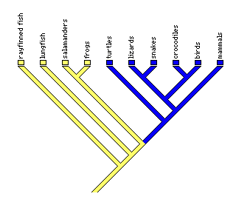

The closer they are together on the map the closer related they are. The oldest species branched off first. For instance, Salamanders and frogs would be more closely related than lungfish and frogs.

Ancestor (oldest)

* There are several different “proofs” for evolution:

**Fossils**- show how organisms changed through time and can show

relationships.

Fossils can be dated in two ways- **relative** or **radiometric dating**

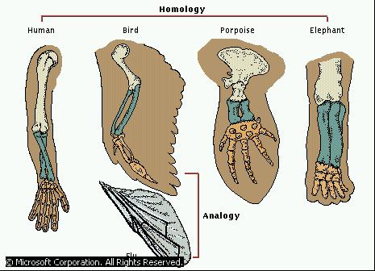

**Anatomical-** by comparing the anatomy

or body structure of organisms we

can determine how closely related they are.

Human, bird, and porpoise are more closely related to each other than the fly. You can tell because their body structure is similar or **homologous**.

* **Biochemical similarities**- by comparing the DNA or the Amino Acids in protein we can determine how closely related organisms are. They closer their DNA and proteins are they closer related they are.

**Classification**

* First classification system was developed by **Aristotle**, but it had a few problems.
* The modern day classification that we use today was developed by **Carolus Linnaeus.** At first there were two kingdoms (animals and plants), then five and now 6.
* The six kingdoms are: plant, animal, protist, fungi, eubacteria, archaebacteria

He classified organisms on their body structure and on many different characteristics.



* **There are 8 levels of classification**

Did Domain

King Kingdom

Philip Phylum

Come Class

Over Order

For Family

Good Genus

Spaghetti Species

* The largest and most general or broad classification would be the Domain and Kingdom.
* The smallest and most specific classification is the species. Organisms can only **interbreed** if they are in the same species.
* The naming system we use today was also developed by Linnaeus. It is called **Binomial Nomenclature**= the 2 name naming system. It is written in **Latin**.

**Common names** can often be confusing so scientists use the

**scientific name**. The scientific name is the same all over the world. This name

has two parts = the **genus and species**.

Genus is always capitalized. The species is not capitalized.

The whole thing is in italics or underlined.

If two organisms are in the same genus it means they are related.

The tiger, house cat, and lion are closely related. We can tell because they all have the same Genus.



* **Dichotomous Key**—this is like scavenger hunt to find out the scientific name of an organisms



1. Has pointed ears .............. go to 3

Has rounded ears ....... .....go to 2

2. Has no tail ................... Kentuckyus

Has tail ........................ Dakotus

3. Ears point upward ................... go to 5

Ears point downward ..............go to 4

4. Engages in waving behavior ..... Dallus

Has hairy tufts on ear...........Californius

5. Engages in waving behavior …… WalaWala

Dallus

**Cladogram**

A cladogram shows an organism’s evolutionary history. It shows what new traits appeared that caused organisms to separate. For instance, the evolution of Lungs separated fish from salamanders. What trait did hamsters get that lizards didn’t have? Fur and mammary glands.

