**Study Guide: Genetics**

* **Gregor Mendel** is considered the father of genetics. He worked with Pea plants to discover the basic concepts of genetics.
* Two important Laws that Mendel developed:

**The law of independent assortment**- this law states that the alleles for each of

our traits are inherited separately. Example brown hair does not have to be

inherited with brown eyes.

**The law of segregation**- this states that our alleles for a trait are separated when

our sex cells are formed (meiosis)

* **Alleles**- different versions of a gene for a trait. Example either Tall (T) or short (t)

(Law of Dominance)

**Dominant**- the trait that takes over or covers up the recessive. (T)

**Recessive**- a trait that gets covered up (t)

**Heterozygous** or **Hybrid**- when a person has two different alleles, Tt.

**Homozygous** or **Pure**- when a person has two of the same alleles, TT or tt.

TT and Tt will show the dominant trait

tt will show the recessive trait.

**Genotype**- the alleles or letters a person has (TT, Tt, tt)

**Phenotype**- the physical trait a person has ex. Tall or short

* **P** generation= parents

**F1**- kids

**F2**- grandkids

* **Simple Mendelian Inheritance:**

Blue is dominant to yellow. A hybrid blue is mated with a yellow.

Tall is Dominant to short.

If a Heterozygous Tall plant is mated with a Pure Tall plant.

B

b

b

b

B

b

B

b

b

b

b

b

T

T

Phenotype

50% blue

50% yellow

Genotype

Bb 50%

Bb 50%

T

T

Phenotype:

100% Tall

Genotype:

TT 50%

Tt 50%

T

T

T

t

T

t

T

t

* **Incomplete Dominance**: this is when both alleles are dominant. (use two big letters). There are three phenotypes. This is where two traits mix.

Red (RR) X white (WW) = Pink (RW)

* **Codominance**: this is when both alleles are dominant. (use two big letters). There are three phenotypes. This is where BOTH traits show up.

Red (RR) X white (WW) = Roan or Red and white (RW)

**Sickle Cell Anemia** is an example of a **codominant** disease. It is more common

in African Americans. It protects someone from **malaria**. It can cause severe



pain. The blood cells are sickle shaped.

You can be normal (NN), a carrier (NS) or have sickle cell (SS). If you are a

carrier you have both normal and sickle blood cells.



If a person who is a carrier and a person who has sickle cell mated

50% would be carriers (NS)

50% would have sickle cell (SS)

* **Multiple Alleles**- this is when you have more than two alleles. An example is blood type.

There are four blood types:

A- AA or Ai

B- BB or Bi

AB- AB

O- ii

O is the recessive blood type and AB is the codominant blood type. The A and B

represent antigens or sugars on the blood cell.

Lori has blood type O. Her husband Bobby has blood type B. His parents were both AB.

Their children could be:

100% B

Diana has blood type AB. Her husband Quentin has blood type A. His parents were A and O.

Their children could be:

25% AB 50% A 25% B





* **Polygenic Inheritance**- these are traits that are controlled by many genes. It results in a variety of traits. Ex. hair and skin color and height.
* **Sex-linked or X-linked-** Sex in on the X! Girls- XX Boys- XY

Sex-linked traits are on the X chromosome. NOT on the Y. When working a

punnett square make sure to use the X’s and Y’s ONLY if it mentions that its

sex-linked. Sex-linked diseases are more common in males because they only have 1 X.

**Hemophilia** is a sex-linked recessive disease. It is when someone’s blood does

not clot and they keep bleeding even from small cuts.

**Red-green colorblindness** is a sex-linked recessive disease. A person cannot tell the

difference between red and green.

Hemophilia is sex linked recessive. Heather has hemophilia and her husband is normal

Colorblindness is sex linked recessive. Holly is a carrier and her husband is colorblind.





50% of the children are colorblind

50% of the girls are colorblind

50% of the boys are colorblind

50% of the children will have hemophilia

0% of the girls have hemophilia

100% of the boys have hemophilia

* There are some genetic diseases that you will have to work with punnett squares with.

**Cystic Fibrosis**- it is a disease that is **autosomal** **recessive** disease

(not- sex linked) and is characterized by the person having a thick mucus

in the lungs and digestive track.



A man is a carrier and his wife has cystic fibrosis

50% of the children normal

50% have the disease

**Huntington’s disease**- In this case the person has nerve damage and results

in death. It is an **autosomal dominant** disease.



A man is normal and his wife is homozygous for Huntington’s.

100% of the children have the disease

* Sometimes in Meiosis the chromosomes fail to separate called **Nondisjunction**

which results in the baby having too many or too few chromosomes.

* **Karyotype** is a picture of someone’s chromosomes and is used to identify

genetic diseases caused by nondisjunction.

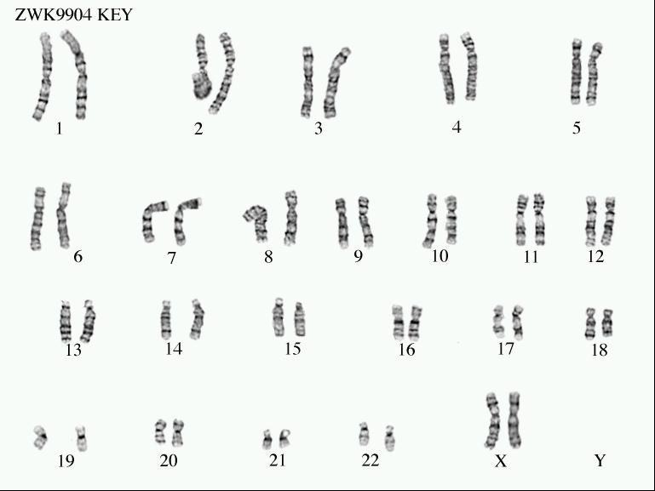

* An **Amniocentesis** is when you take fluid from a pregnant woman and

do a karyotype to determine if the unborn baby has a genetic disease

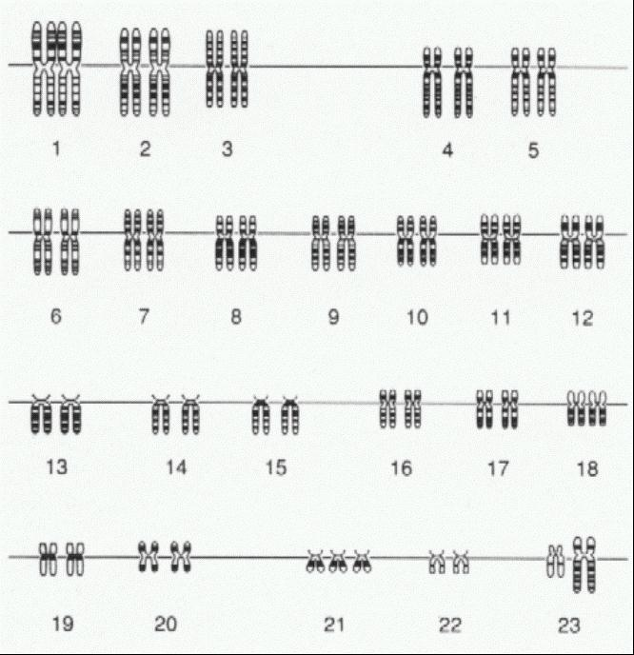

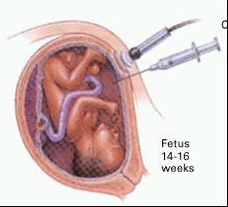

* **Down’s Syndrome**- this is caused by nondisjunction.

The person has three 21 chromosomes and so a total

of 47 chromosomes. It can also be called trisomy 21.

This person has a low IQ.

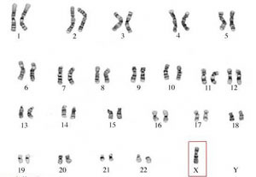

* **Turner’s Syndrome**- This is a disease also caused

by nondisjunction. It is when a girl is missing an X.

So she only has 45 chromosomes. It is often represented by XO.

**Pedigrees**

A pedigree is a family tree to show how a family inherits their trait.

A is a girl. A is a man. If it is colored in then they have the trait or disease.

If the trait is in every generation then it is a dominant trait

If the trait is in only a few people and it’s in boys and girls than it is recessive.

If it’s in only a few people and they are mostly boys then it is sex-linked recessive



Autosomal Recessive



Sex linked recessive

* Remember that if the parents are normal and the child has the disease then the parents must be heterozygous.
* Genetics and Environment:

There are some diseases that are caused by your genes but also by your environment:

**Diabetes, Asthma, Heart or Cardiovascular disease and Cancer**.

You could have these diseases in your DNA OR you could live in a way that

causes you to get these diseases.

Some traits are caused by only the environment, only genetics, or can be caused by an interaction between both. Be able to analyze a situation and tell me if it is genetic, environment or both.