**Midterm Study Guide**

**DNA**

* **DNA**- **Deoxyribonucleic acid**. This is what makes you, you! It is located in the **nucleus** of every cell in your body.
* It is a **nucleic acid** which means it is made of **nucleotides**.

A **nucleotide** is made of three things- **a phosphate, sugar, and a base**.

* The sugar in DNA is **deoxyribose** (look at its name).

There are 4 bases- **Adenine**, **Thymine**, **Guanine,** and **Cytosine**.

A goes with T G goes with C

* The bonds that connect the bases are called **hydrogen bonds** which are weak so the DNA can unzip. The strong bonds which connect the sugars and the phosphates are **covalent bonds**.
* **Watson and Crick** discovered the shape of DNA which is a **double helix**.

**Hydrogen Bond**

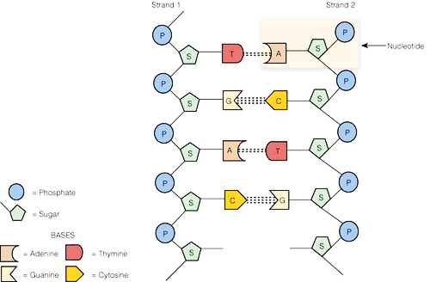

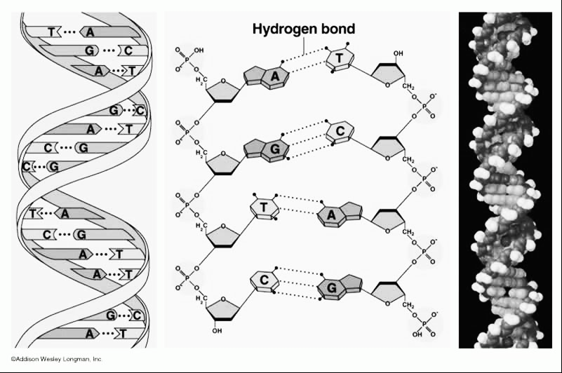

**Covalent bond**

**DNA replication** is how we make **more DNA**. It happens during the **“S” or Synthesis phase** of interphase. DNA has to be replicated before your body can make new cells or **before cells divide**. This happens in the **nucleus**. DNA is **semi-conservative** because the new strand of DNA have one strand from the “old” DNA and one “new” or complementary strand of DNA.

The DNA unzips down the middle by breaking the hydrogen bonds and then bases come and match up. The new matching strand is called the **complementary strand**. This makes two identical strands of DNA.

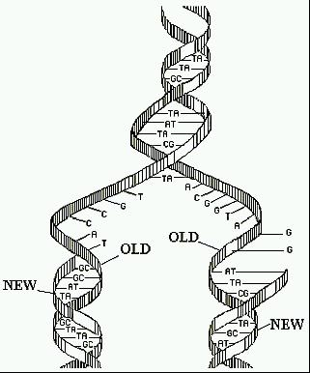

* You should be able to match up

DNA during replication like below:

If DNA is **AGCTTACTTGG** The **complementary strand** would be **TCGAATGAACC**

* DNA can come in different formats but it is all DNA.

**Chromatin**- this is how DNA spends most of its time. It is long stringy DNA

**Chromosomes**- this is when DNA coils up every tightly and becomes short and

thick. This happens when the cell needs to divide.

**Gene**- this is a segment of DNA that codes for a specific protein or trait

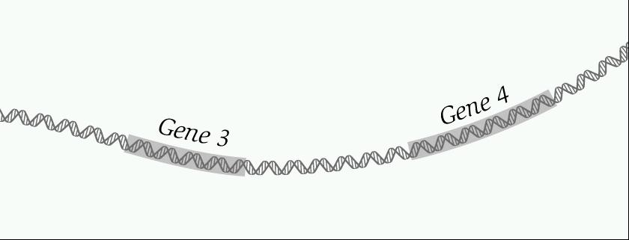

* **Mutations**- Sometimes when DNA is replicating there are mistakes called mutations. Mutations **can be good or harmful**. They **cause variations** and are passed on to offspring if they occur in the gametes. Mutations can be random and spontaneous or caused by **exposure to a chemical or radiation**.
* **Addition or insertion mutations**: adding a base to the DNA strand
* **Deletion mutation**: deleting a base from the DNA strand
* **Point mutations**: Changing one base to another. For instance changing a “G” to a “T”.

**RNA**

* **RNA**- Ribonucleic acid- used to make proteins
* This is another type of **nucleic acid**. It is also **made of nucleotides**.

The sugar is **ribose**.

It is single stranded and has **Uracil** instead of Thymine.

So U goes with A G goes with C

* mRNA is **made in the nucleus** from DNA and the process is called **Transcription**.
* Be able to match up the correct RNA with the DNA like below:

DNA Strand: AGCTTCTTAGGC

RNA Strand: UCGAAGAAUCCG

* There are three types of RNA:

**mRNA**- messenger RNA—it takes the message from the DNA to the ribosome

**tRNA**- transfer RNA- it bring the amino acids to the ribosome

**rRNA**- ribosomal RNA- this makes up the ribosome

**Codon**- every three bases on an mRNA strand. Used to find the amino acid.

**Anticodon**- three bases on the tRNA

The codon and anticodons will match up during translation.

**Translation**- when the cell **makes a protein** from RNA. Happens **in the ribosome**

1. the mRNA hooks into the ribosome
2. the tRNA brings in the amino acid- anticodon matches up with codon
3. a peptide bond forms between the amino acids making a protein or polypeptide chain.

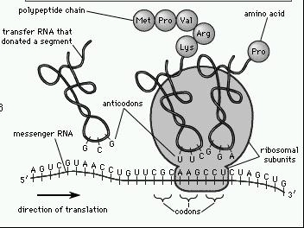

**Translation**

**mRNA**

**Ribosome**

**tRNA**

* In order to find out what amino acid will match up we must use the amino acid chart. We look at the codons on the mRNA to find out the amino acid.

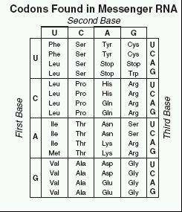

Ex. If mRNA codon is CCG then the amino acid from the chart is Pro

If DNA is TGA then the mRNA is ACU and the amnion acid is Thr

**Translation**

**Transcription**

**Trait or Phenotype**

**DNA**

**Protein**

**RNA**

* If a mutation occurs in the DNA or RNA then the protein will change which will result in a different phenotype.

**Genetics**

* **Gregor Mendel** is considered the father of genetics. He worked with Pea plants to discover the basic concepts of genetics.
* Two important Laws that Mendel developed:

**The law of independent assortment**- this law states that the alleles for each of our traits are inherited separately. Or the genes get shuffled. Example brown hair does not have to be inherited with brown eyes. **Creates Variation.**

**The law of segregation**- this states that our alleles for a trait are separated when our sex cells are formed (meiosis)

* **Alleles**- different versions of a gene for a trait. Example either Tall (T) or short (t)

**Dominant**- the trait that takes over or covers up the recessive. (T)

**Recessive**- a trait that gets covered up (t)

**Heterozygous** or **Hybrid**- when a person has two different alleles, Tt.

**Homozygous** or **Pure**- when a person has two of the same alleles, TT or tt.

TT and Tt will show the dominant trait tt will show the recessive trait (all small!)

**Genotype**- the alleles or letters a person has (TT, Tt, tt)

**Phenotype**- the physical trait a person has ex. Tall or short

* **P** generation= parent **F1**- kids **F2**- grandkids
* **Simple Mendelian Inheritance:**

Tall is Dominant to short.

If a Heterozygous Tall plant is mated with a Pure Tall plant.

Blue is dominant to yellow. A hybrid blue is mated with a yellow.

Phenotype

50% blue

50% yellow

Genotype

Bb 50%

Bb 50%

B

b

b

b

B

b

B

b

b

b

b

b

T

T

Phenotype:

100% Tall

Genotype:

TT 50%

Tt 50%

T

T

T

T

T

t

T

T

t

t

* **Incomplete Dominance**: this is when both alleles are dominant. (use two big letters). There are three phenotypes. This is where **two traits mix**.

Red (RR) X white (WW) = Pink (RW)

* **Codominance**: this is when both alleles are dominant. (use two big letters). There are three phenotypes. This is where **BOTH traits show up**.

Red (RR) X white (WW) = Roan or Red and white (RW)

**Sickle Cell Anemia** is an example of a **codominant** disease. It is more common

in African Americans. It protects someone from **malaria**. It can cause severe



pain. The blood cells are sickle shaped.

**You can be normal (NN), have Sickle trait (NS) or have sickle cell (SS).** If you are a

carrier you have both normal and sickle blood cells.

If a person who is a carrier and a person who has sickle cell mated

50% would be carriers (NS)

50% would have sickle cell (SS)



* **Multiple Alleles**- this is when you have more than two alleles. An example is blood type.

There are four blood types:

**A- AA or Ai**

**B- BB or Bi**

**AB- AB**

**O- ii**

O is the recessive blood type and AB is the codominant blood type. The A and B

represent antigens or sugars on the blood cell.

Diana has blood type AB. Her husband Quentin has blood type A. His parents were A and O.

Their children could be:

25% AB 50% A 25% B

Lori has blood type O. Her husband Bobby has blood type B. His parents were both AB.

Their children could be:

100% B





* **Polygenic Inheritance**- these are traits that are controlled by many genes. It results in a variety of traits. Ex. hair and skin color and height.
* **Sex-linked or X-linked-** Sex in on the X! Girls- XX Boys- XY

Sex-linked traits are on the X chromosome. NOT on the Y. When working a

punnett square make sure to use the X’s and Y’s ONLY if it mentions that its

sex-linked. Sex-linked diseases are more common in males because they only have 1 X.

**Hemophilia** is a sex-linked recessive disease. It is when someone’s blood does

not clot and they keep bleeding even from small cuts.

**Red-green colorblindness** is a sex-linked recessive disease. A person cannot tell the

difference between red and green.

Colorblindness is sex linked recessive. Holly is a carrier and her husband is colorblind.



Hemophilia is sex linked recessive. Heather has hemophilia and her husband is normal



50% of the children will have hemophilia

0% of the girls have hemophilia

100% of the boys have hemophilia

50% of the children are colorblind

50% of the girls are colorblind

50% of the boys are colorblind

There are some genetic diseases that you will have to work with punnett squares with.

**Cystic Fibrosis**- it is a disease that is **autosomal** **recessive** disease

(**not- sex linked**) and is characterized by the person having a **thick mucus**

in the lungs and digestive track.



A man is a carrier and his wife has cystic fibrosis

50% of the children normal

50% have the disease

**Huntington’s disease**- In this case the person has **nerve damage** and results

in death. It is an **autosomal dominant** disease.



A man is normal and his wife is homozygous for Huntington’s.

100% of the children have the disease

* Sometimes in Meiosis the chromosomes fail to separate called **Nondisjunction**

which results in the baby having too many or too few chromosomes.

* **Karyotype** is a picture of someone’s chromosomes and is used to identify

genetic diseases caused by nondisjunction.

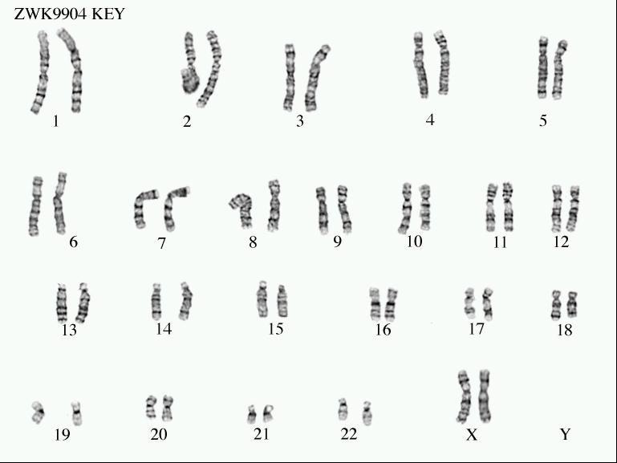

girl

* An **Amniocentesis** is when you take fluid from a pregnant woman and

do a karyotype to determine if the unborn baby has a genetic disease

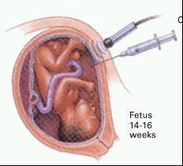

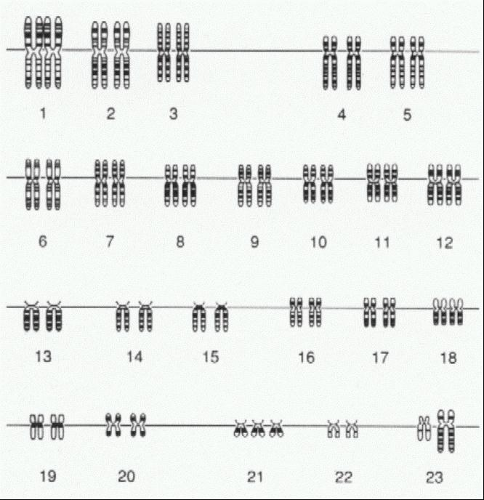

* **Down’s Syndrome**- this is caused by nondisjunction.

The person has three 21 chromosomes and so a total

of 47 chromosomes. It can also be called trisomy 21.

This person has a low IQ.

Boy

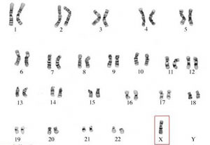

**Turner’s Syndrome**- This is a disease also caused

by nondisjunction. It is when a girl is missing an X.

So she only has 45 chromosomes. It is often represented by XO.

* There are some diseases that are caused by your genes but also by your environment:

**Diabetes, Asthma, Heart or Cardiovascular disease and Cancer**. Remember traits can be entirely based on genetics entirely based on environment, or both. You could have these diseases in your DNA OR you could live in a way that causes you to get these diseases.

**Pedigrees**

A pedigree is a family tree to show how a family inherits their trait.

A is a **girl.** A is a **man**. If it is **colored in then they have the trait or disease**.

If the trait is in every generation then it is a dominant trait

If the trait is in only a few people **and it’s in boys and girls than it is recessive**.

If it’s in only a few people and they are **mostly boys then it is sex-linked recessive**



Autosomal Recessive



Sex linked recessive

* Remember that if the parents are normal and the child has the disease then the parents must be heterozygous.

**Mitosis and Meiosis**

Our bodies need to make more cells- there are two types of cells and two types of

processes that our bodies do.

|  |  |
| --- | --- |
| **Mitosis** | **Meiosis** |
| “toes”= makes body cells/ **somatic** cells | Me=Se This makes sex cells/ **gametes** |
| Makes 2 cells | Makes 4 cells |
| ALL of their chromosomes, 2 sets, 2n = **Diploid** Cells | have ½ of chromosomes, 1 set, 1n = **haploid** |
| Makes identical cells or clones | makes different cells or variation |
| **Asexual** reproduction | **sexual** reproduction |

If a cat has a body cell of 80 chromosomes than they sperm will have? 40

* If an egg of a fish has 100 chromosomes then the tail would have? 200

**Mitosis:** The **Cell Cycle** is a process where **body cells** grow, make copies of chromosomes, and divide to make new cells.

In **Interphase** the cell is living its life (STERNGRR). There are three parts of Interphase:

Growth 1 (**G1**): The cell grows and doubles organelles

Synthesis (**S**): More DNA is made by **DNA replication**

Growth 2 (**G2**): The cell continues to grow getting ready to divide

Then the cell will divide in two through **Mitosis** or the M phase.

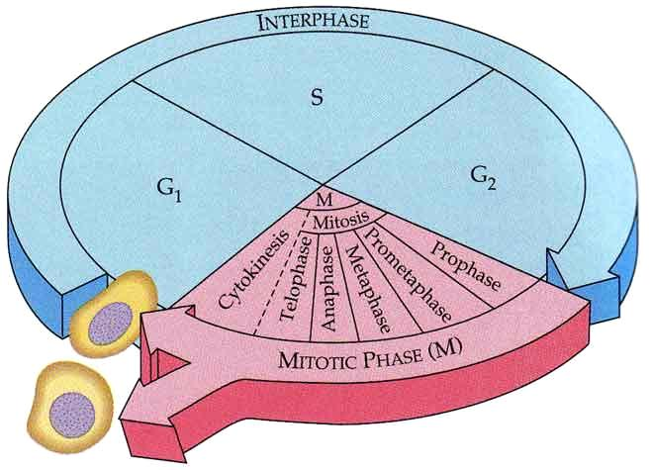

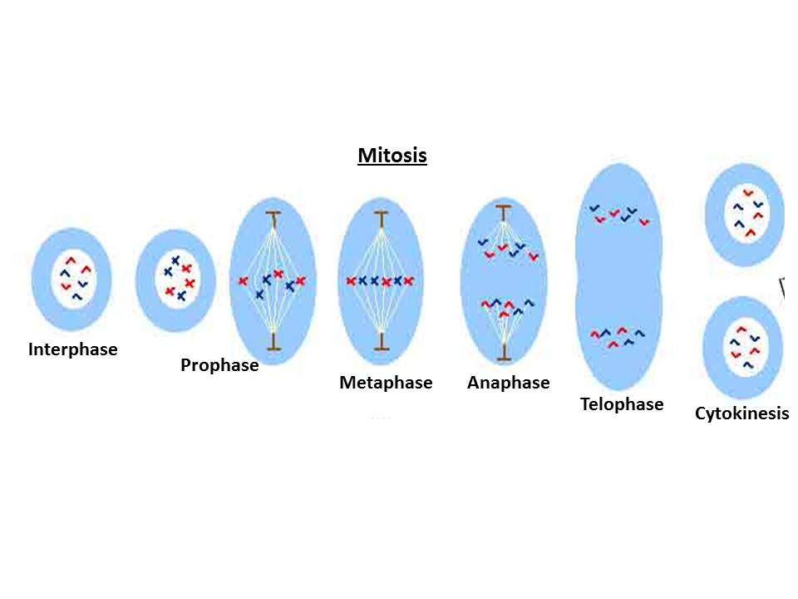

Start

Makes 2 cells with the same chromosomes as the parent

*Bacteria and protists reproduce asexually through **mitosis** where they divide in two making identical clones called **binary fission**.

*Sometimes there is a mutation in the DNA which leads to out of control mitosis divisions. This uncontrolled mitosis results in **cancer**.

**Meiosis** is the processes where sex cells/gametes (egg and sperm) are made.

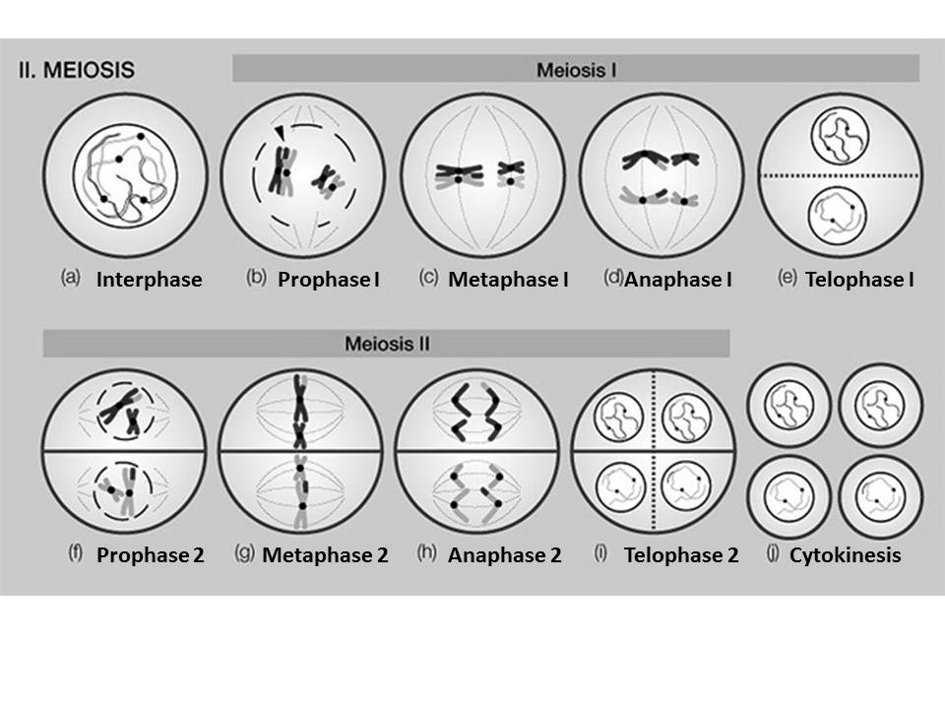

**Ends with 4 cells with half the number of chromosomes and a unique combination**

* In Meiosis sometimes the chromosomes will trade pieces- this **provides variety** and is called **crossing over.** During Meiosis the genes are “shuffled” called **Independent Assortment** which also **creates variation.**
* **Homologous chromosomes** are chromosomes that code for the same trait. They **pair up** in meiosis during metaphase 1 before splitting apart. Mitosis has pairs of homologous chromosomes in the final cell “2n”. BUT meiosis does not have pairs so only has “n” chromosomes at the end (half).
* When a sperm and Egg come together this is **fertilization** and forms a **zygote** (baby).
* The Human diploid number is **46** and the haploid number in our egg and sperm is **23**.

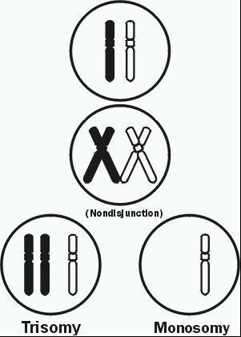

* Sometimes in Meiosis the chromosomes fail to separate called **Nondisjunction**

which results in the baby having too many or too few chromosomes.

**Study Guide: Biochemistry**

* A **Macromolecule or polymer** is a large molecule. If a molecule had carbon than it is considered an **Organic molecule**.
* There are four main macromolecules that are important to biology:

**carbohydrates, lipids, proteins, and nucleic acids**

* These large macromolecules are made of small pieces or building blocks called **monomers or subunits**.

**Carbohydrates**- these are sugars used for quick energy. Their building blocks or monomers are **monosaccharides**. Remember many sugars end in -ose

**Monosaccharides**---- one sugar----examples **Glucose** which is made in photosynthesis

**Fructose** which is in honey and fruit



Glucose

**Disaccharides**--2 sugars or 2 monosaccharides connected---

Example **sucrose** which is table sugar

**Polysaccharides**---many sugars- examples: **Cellulose** which is in cell walls

**Starch** which is used for plant energy storage

**Glycogen** which is used for animal energy storage in the liver

**Lipids**- these are fats, waxes and oils. They are used for long term energy storage and for the cell membrane. Also used for insulation to protect animals from the cold.

**Monomer or subunit**- is a fat made of a glycerol backbone and three fatty acid chains.

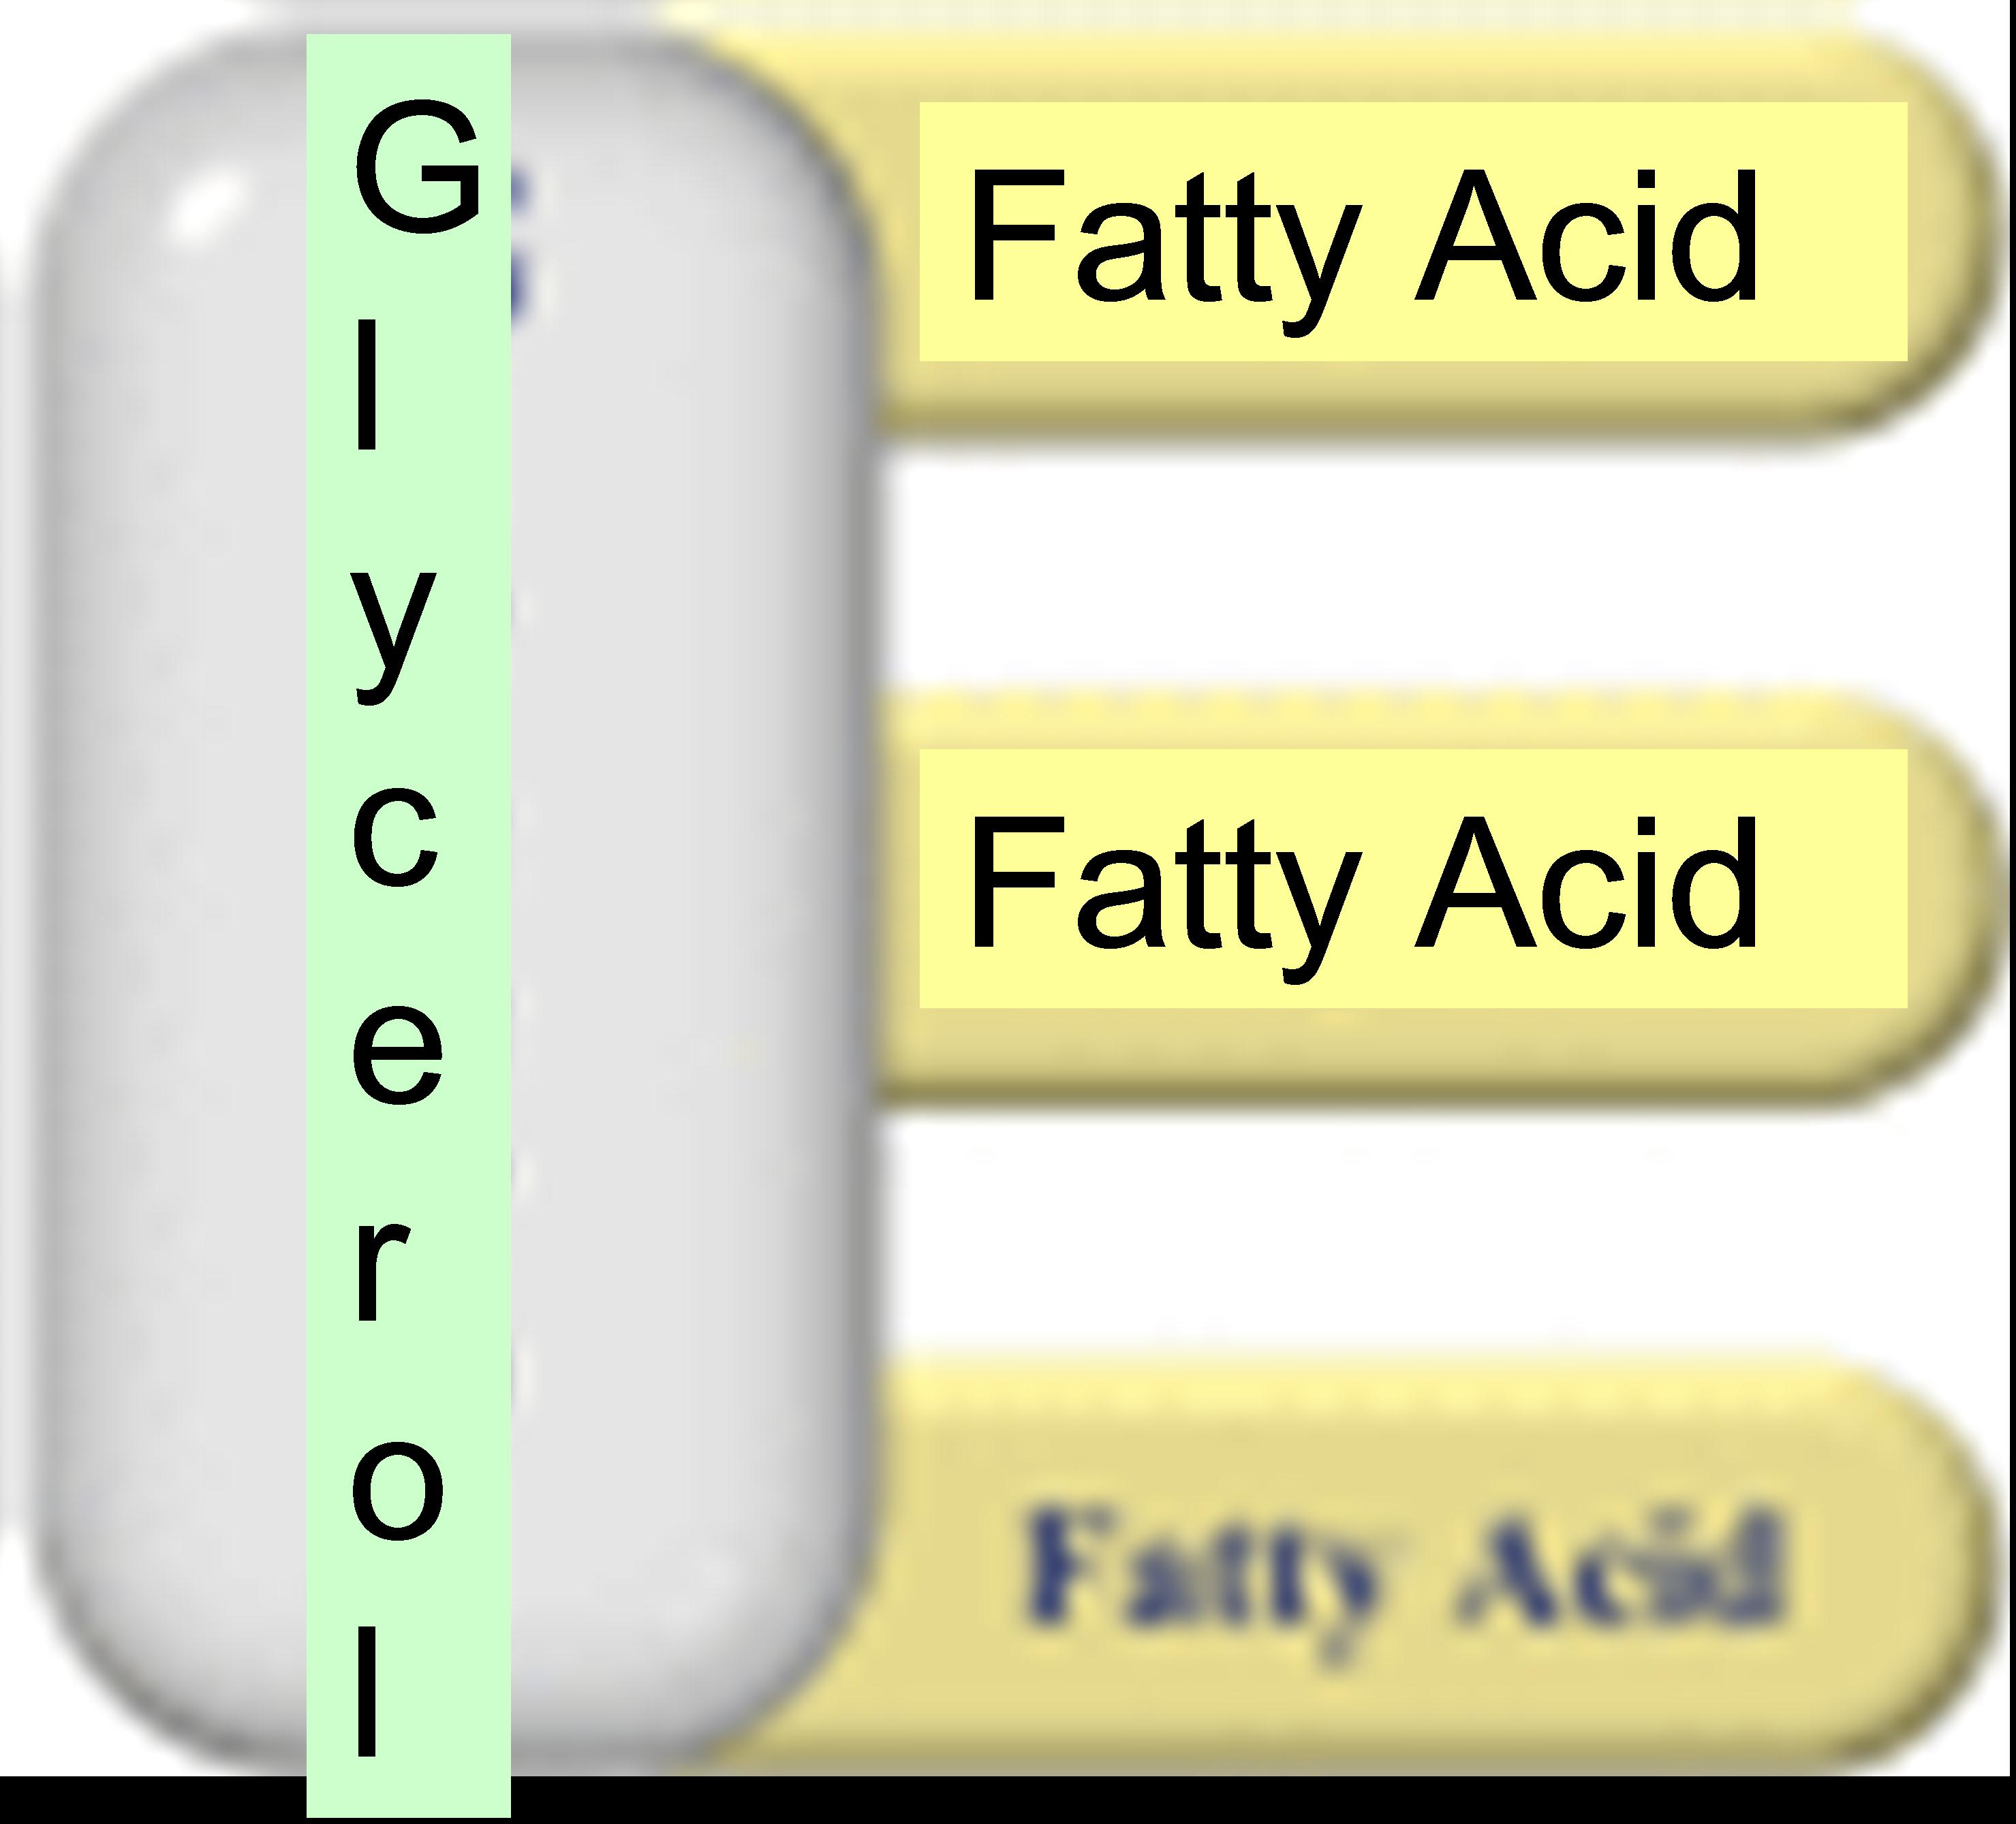

**Phospholipids:** fats that make up the cell membrane

**Steroids:** fats which are in rings instead of chains like cholesterol. Control signals in the body like hormones. Testosterone, estrogen

Examples of lipids:

**Proteins**- Made from **amino acids** which are held together by **peptide bonds**. There are 20 amino acids. They are made in the **ribosome**. Proteins fold in a 3D shape and this shape determines their function. They help **repair tissue**.



Important Proteins:

**Enzymes** (see enzymes in this packet)

**Hemoglobin**- a protein in a blood cell that helps carry oxygen in the blood.

**Insulin-** a protein in the body which helps maintain proper blood sugar levels. If there are problems making insulin than a person could have diabetes.

**Nucleic Acids**:

These molecules are our **inherited genetic information**. And also are the **instructions for proteins**

The two main examples are **RNA and DNA**

They are made of **Nucleotides**. Nucleotides are made of a **phosphate, sugar, and base**.

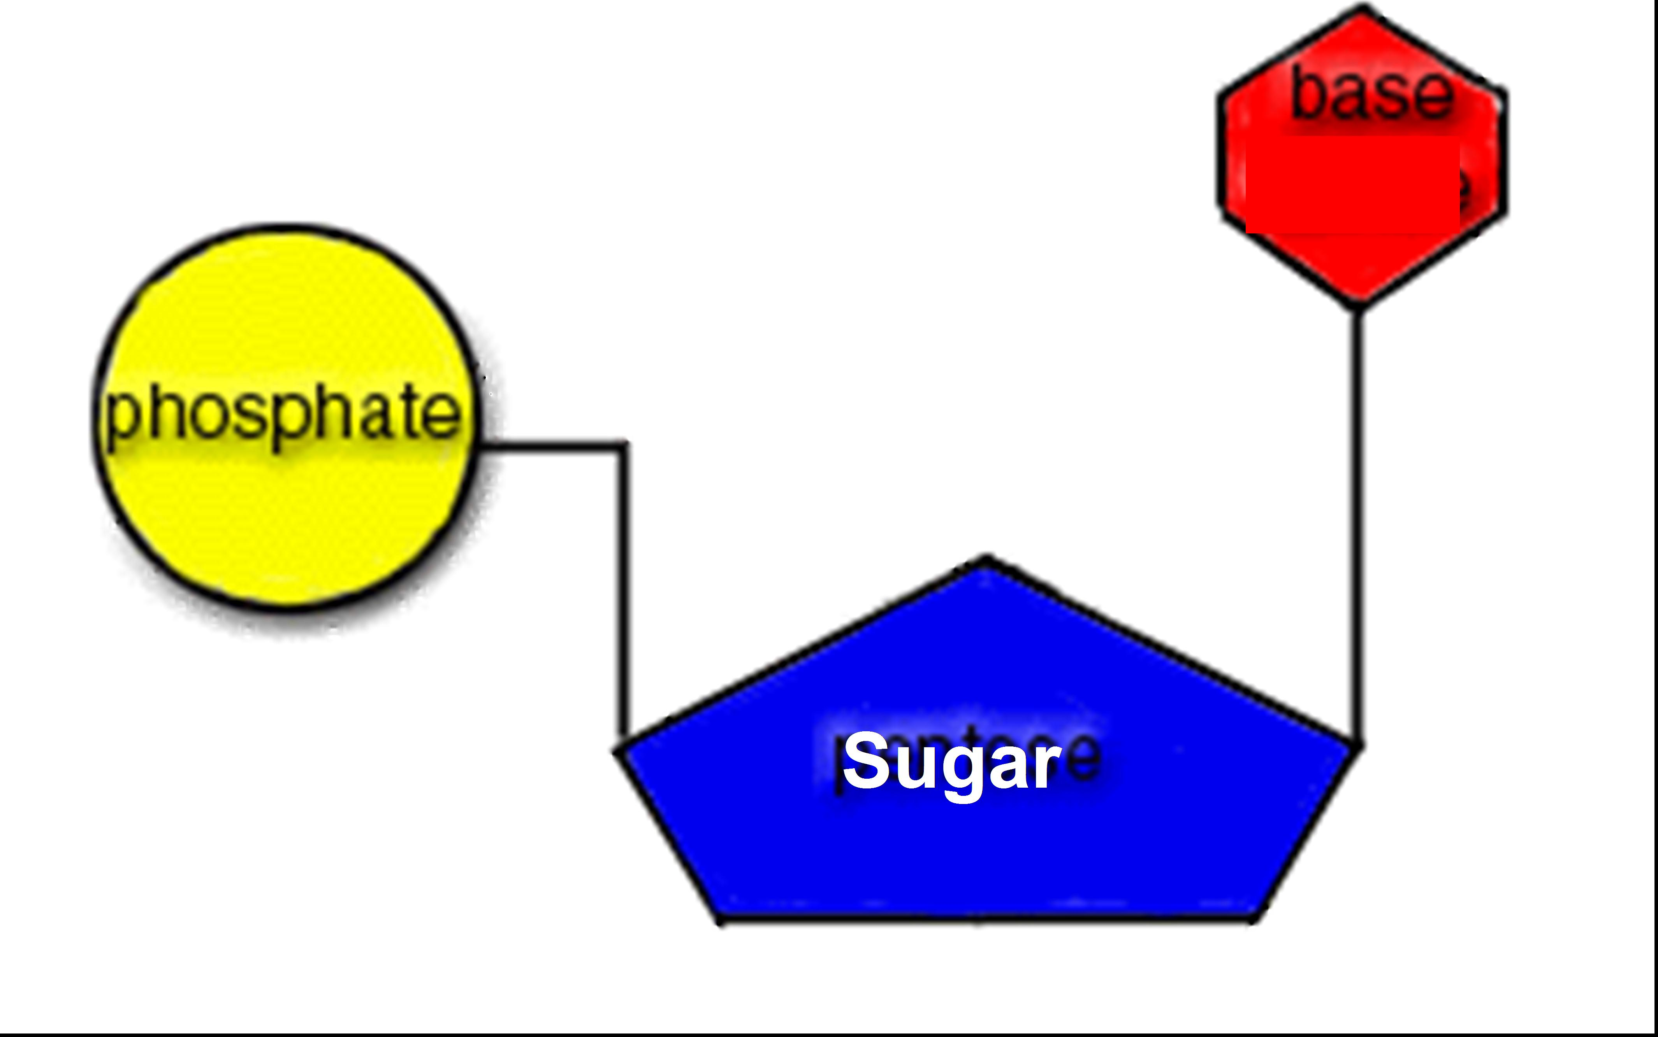

## Enzymes

* **Enzymes** can also be called **Catalysts**. Several enzymes end with –**ase**.

Ex. Lactase, Maltase. They can be used over and over again.

* These are proteins that help **speed up reactions**. Without them most of the reactions that happen in our body would happen so slowly that we would die. They are **reusable or recyclable**.
* People who lack the enzyme **Lactase are Lactose intolerant**. Meaning they cannot break down the sugar, lactose, in dairy products. So if they were to drink milk they would have an upset stomach.
* Every reaction needs a certain amount of energy to start (**activation energy**). Enzymes **lower the amount of reaction energy needed**. So since the reaction doesn’t need as much energy it can go faster.

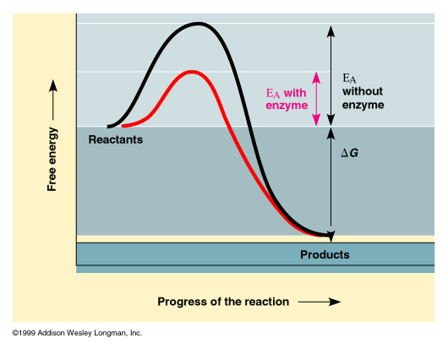

**With Enzyme**

**Without Enzyme**

* Enzymes fit together with **substrates**. Substrates are whatever chemical the enzyme is working on. They fit like **a lock and key**. Enzymes only fit their **specific** substrate.
* The place where the substrate fits into the enzyme is called the **active site**.

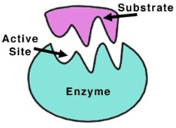

* If you change the shape of the enzyme it won’t work anymore. You can do this by changes in temperature or pH level. Its called **denaturation**.

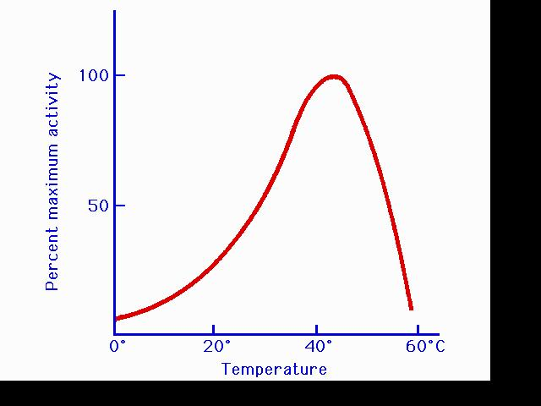

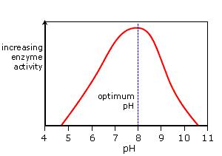

*Remember the words **optimum** and **optimal** mean best or highest!

**Acids and Bases**

pH is a measurement of how acidic or basic a solution is.

Less than 7 is an acid 7 is neutral More than 7 is a base

**This might help you remember**:

A before B

1 before 14

# Study Guide: Cells

* Cells are the smallest living things. Cells make tissues, tissues make organs, and organs make an organism (living thing).

Cells Tissue Organ Organism

Muscle Cell Muscle Tissue Heart Human

* To see a cell you must use a microscope. To determine the magnification: Lens x Eyepiece= magnification. Example. Lens= 10x and Eyepiece = 40x so 10 X 40= 400x magnification.

There are two main types of cells: Prokaryotes and Eukaryotes

* **Prokaryotes** do NOT have a nucleus or any other organelles.

They do have ribosomes and DNA. Their DNA can be a plasmid.

They are small, microscopic and unicellular.

Take the “p” and turn it upside down for a “b”= Bacteria!

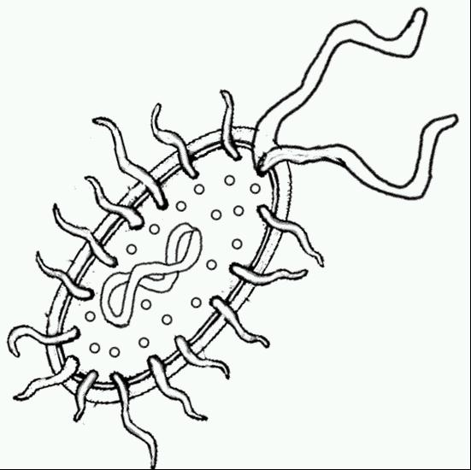

Flagella

Ribosomes (the dots)

DNA or Plasmid

Cell Membrane

Cilia

A plasmid is circular DNA.

Cell wall

* **Eukaryotes** DO have a nucleus and all organelles.

Animals, plants, protists and fungi are all eukaryotes.

Can be multi or unicellular and are larger.

**Important Organelles**:

|  |
| --- |
| P & A |
| P, A,& B |
| P, A, & B |
| P & A |
| P & B |
| P |
| P |

**A. Nucleus**- “the brain of the cell” Controls all cell functions. DNA is inside.

**B. Cell/plasma membrane**- controls what enters and leaves the cell. Homeostasis

**C. Ribosomes**- these make the proteins in the cell

**D. Mitochondria**- “powerhouse” of the cell. Provides energy by Cellular respiration.

**E. Cell wall**- this is not in animals. Provides protection and support for the cell

**F. Chloroplast**- this is only in plants and protists. This is where photosynthesis happens. It contains a pigment called **chlorophyll** which keeps the plant green and captures light energy.

**G. Vacuole**- Large vacuole only in plants. It stores food, water, enzyme, and waste.

**Protists:** They are Eukaryotes because they have a nucleus and organelles

Most protists live in water. Many of them have **contractile vacuoles.** An organelle that helps cells maintain water balance (homeostasis). Excess water is temporarily stored in the vacuole. Then the vacuole contracts to pump the excess water out of the cell.

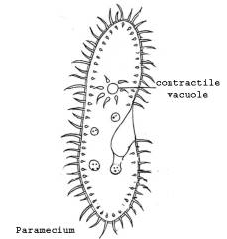

The Animal like protists-

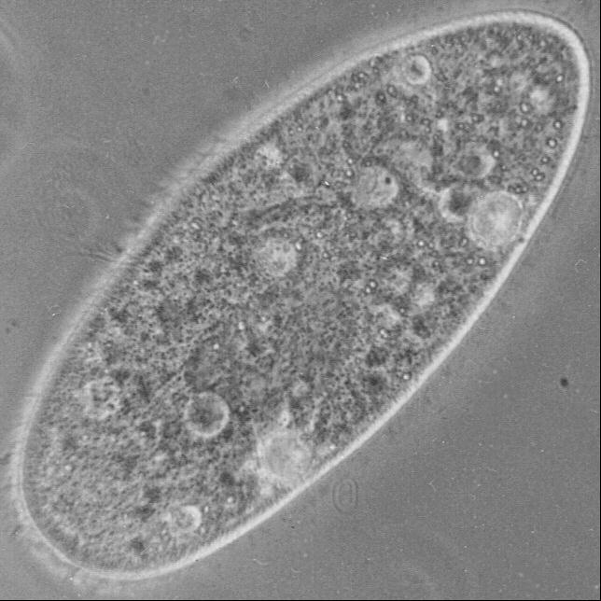

**Paramecium**

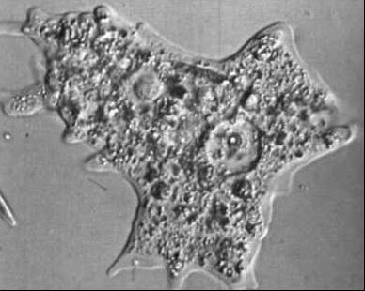

**Amoeba**

Heterotrophs (eat) - absorb their food through membrane

-oral and anal pore- a crude mouth and butt

-**Pseudopods-** “false feet” Parts of the cell membrane used to

engulf food.

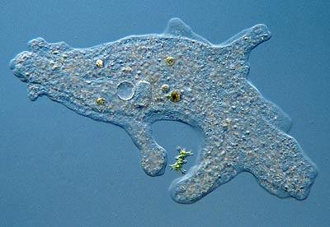

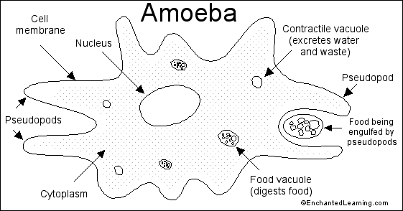

Autotrophs (plant like protists) – do photosynthesis using chloroplast, but can also catch prey

**Euglena**

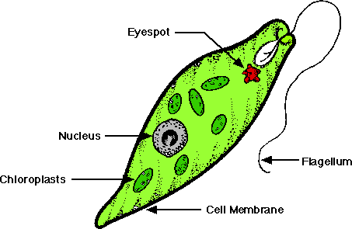

Euglena have **eyespots** which are organelles sensitive to light. The eyespot lets Euglena know where to move so they will have light for photosynthesis.