**Study Guide: Energy**

**Photosynthesis**= putting together with light

* This is the process where **producers/autotrophs** make their own food (glucose). The energy for this reaction is from the sun. Sun energy is called radiant energy.
* Plants turn **radiant energy** (sun) into **chemical energy** (glucose).
* **Reactants** (ingredients) = water, carbon dioxide, and light

(remember plants are opposite of us...we breathe in oxygen they breath in CO2)

**Products** (what you get) = glucose and oxygen

* You must know the formula:

Light



* Photosynthesis happens in the **chloroplast** of the cell. Since animals do not have chloroplasts they cannot perform photosynthesis. The **chlorophyll** is pigment in the chloroplast that absorbs the sunlight and makes the plant green.
* The Carbon dioxide enters the leaf and the oxygen leaves the leaf through an opening called the stomata or stoma. The **stomata** are surrounded by guard cells.



Guard cells

The stoma or stomata

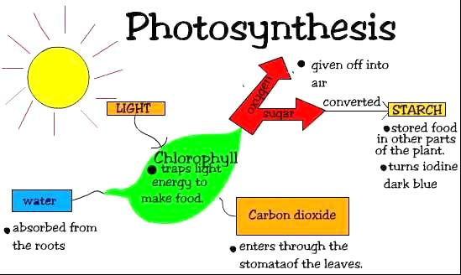

Gives off oxygen

Glucose= a Carbohydrate or sugar

Chloroplast

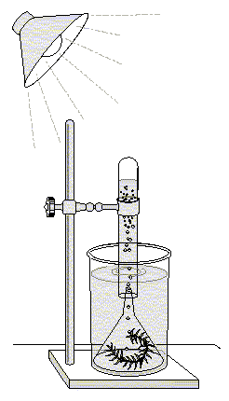

This is an elodea plant which is a water plant. When exposed to light little bubbles appear in the water. What are the bubbles? Oxygen...the plant makes it when it is doing photosynthesis from the light.

The more light the more bubbles. The more CO2...the more bubbles.

Because more ingredients more oxygen (product)

* Plants have **vascular tissue**: the veins in the leaf. There are two kinds: **Xylem** carries water up from the roots to the leaves and **Phloem** carries sugar down from the leaves to the roots.

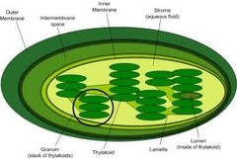

The **chloroplast**. Remember it has stacks on the inside that look like pancakes = sugar!

**Cellular Respiration** – this is how cells break down the glucose made in photosynthesis to release energy. All living things do respiration all of the time.

* Respiration happens in the **mitochondria** of the cell. This is why we call the mitochondria the power house of the cell because it is releasing energy.

The **mitochondria**. Remember it looks like a bean with a river in it.

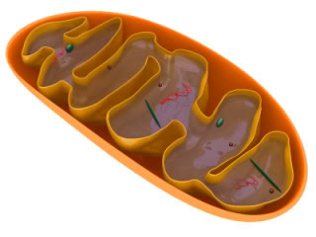

* Respiration is the opposite of photosynthesis.
* **Reactants** (ingredients) = glucose and oxygen

**Products** (what you get) =water, carbon dioxide and energy (ATP)



(ATP)

* There are two types of respiration-

**Aerobic**- respiration that uses oxygen. Makes more energy or 36 ATP.

**Anaerobic**- does not use oxygen (“An” means not).

Makes less energy only 2 ATP.

* Another name for Anaerobic respiration is **Fermentation**.

There are two types of anaerobic respiration or Fermentation:

**Lactic Acid Fermentation**- this makes lactic acid. This is the type of

respiration our muscles do when they run out of oxygen. It is why our

muscles get sore. Bacteria also make lactic acid.

**Alcohol Fermentation**- this is the type of fermentation that is done by yeast.

It makes alcohol and can make it from apple juice.



If we put apple juice or glucose and yeast into a test tube, the yeast will make alcohol. But it will also make some bubbles. What are the bubbles? Carbon Dioxide which is made as the yeast does alcohol fermentation or anaerobic respiration.

|  |  |
| --- | --- |
| **Photosynthesis** | **Respiration** |
| Uses water, light and CO2 | Uses Oxygen and Glucose |
| Makes Oxygen and glucose | Makes water, CO2 and energy (ATP) |
| Happens in chloroplast | Happens in mitochondria |
| Happens in producers | Happens in all living things all the time |
|  | Has two types: aerobic and anaerobic |

**ATP**- is the energy molecule that is made in respiration. It is how our bodies temporarily store the energy made in respiration. The **energy is in the bonds of the molecule**.