Hopewell High School


Cambridge Program
2016 Yearlong A/B IGCSE Biology

Teacher: Beth Urbina Room: 201
School number: 980-343-5988 Email: betha.stapperfenne@cms.k12.nc.us
Course name: IGSCE Biology Wiki Page Address: http://stapperfenne.weebly.com/

Tutoring/Retest/Recovery Schedule: Tuesdays and Thursdays 2:30-3:30

Professional Background: This is my 11th year teaching science. I taught for 8 years in Winston-Salem and this is my third year at Hopewell. I have experience teaching Biology, Honors Biology, Greenhouse Biology, IGCSE Biology, Earth/Environmental Science, and Physical Science. I graduated from NCSU with a BS in Biological Sciences, BA in Chemistry and a minor in Genetics. I earned my Masters in Education from Wake Forest University. I also have the honor of being a National Board Certified Teacher.

Text: Cambridge IGSCE Biology 3rd edition, Cambridge University Press, Jones & Jones
The Immoral Life of Henrietta Lacks, Broadway Paperback, Rebecca Skloot

Course Description: Cambridge programs develop not only subject knowledge but also skills. We encourage Cambridge students to be:
• Confident in working with information and ideas—their own and those of others
• Responsible for themselves, responsive to and respectful of others
• Reflective as students, developing their ability to learn
• Innovative and equipped for new and future challenges
• Engaged intellectually and socially, ready to make a difference

IGSCE Biology will incorporate these Cambridge learner attributes while teaching students an overview of the chemical, physical, and cellular basis of life. During this course, students learn basic cell structure and function, basic genetics and genetic technology, ecology and human impact on the environment, as well as evolution and classification. Please understand this class is about inquiry and the teacher as a facilitator. Therefore, you will not always be given the information upfront to memorize, but rather be supported and scaffolded by the teacher as you do labs, research, activities, and readings to learn the content.

Course Standards: This course is based on the Cambridge IGCSE Biology Syllabus for 2016 and NC Essential Standards.
 |  | IGCSE 1-Characteristics and classification of living organisms  IGCSE 2-Organization of the organism  IGCSE 9-Transport in animals | IGCSE 1.1
  Bio 1.1 -Understand the
  relationship between the
  structures and functions of
  cells and their organelles.
  Describe the characteristics of living organisms by defining the terms: movement,
  respiration, sensitivity, growth, reproduction, excretion, and nutrition.
  Summarize structure and function of organelles in eukaryotic cells and ways that these organelles interact with each other to perform the function of the cell. Plant and animal
  cell differences and similarities.
Bio.1.1.1
IGCSE 1.3, 2.1
 |  |  | Bio 1.1.2  IGCSE 2.3
  Compare prokaryotic and eukaryotic cells in terms of their general structures
  (plasma membrane and genetic material) and degree of complexity.
  Bio.1.1.3
  IGCSE 9.4
  Explain how instructions in DNA lead to cell differentiation and result in cells
  specialized to perform specific functions in multicellular organisms.
  Blood cell: components, functions and identification.
 |  | IGCSE 3-Movement in and out of  cells  IGCSE 11-Gas exchange in humans  IGCSE 13-Excretion in humans  IGCSE 14-Coordination and response  IGCSE 16-Reproduction  IGCSE 17-Inheritance  IGCSE 18-Variation and selection
  Bio 1.2 Analyze the cell as
  a living system.
  Bio.1.2.1
  IGCSE
  3.1-3.3, 11,
  13, 14.4
  Explain how homeostasis is maintained in the cell.
  Diffusion, Osmosis, Comparison of passive and active transport. Gas exchange
  in humans. Explain what factors affect the volume and concentration of urine.
 |  |  | Bio.1.2.2  IGCSE 16.1, 17.3, 18.1 | Analyze how cells grow and reproduce in terms of interphase, mitosis and cytokinesis.
 |  |  | Bio.1.2.3 | Explain how specific cell adaptations help cells survive in particular environments (focus on unicellular organisms).
Bio 2.1 Analyze the interdependence of  living organisms within their environments. |  | IGCSE 19-Organisms and their environment  IGCSE 21-Human influences on ecosystem | Bio.2.1.1  IGCSE 19.1-19.3, 21.2 | Analyze the flow of energy and cycling of matter (water, carbon, nitrogen and oxygen) through ecosystems relating the significance of each to maintaining the health and sustainability of an ecosystem.
 |  |  | Bio.2.1.2 | Analyze the survival and reproductive success of organisms in terms of behavioral, structural, and reproductive adaptations.
 |  |  | Bio.2.1.3 | Explain various ways organisms interact with each other (including predation, competition, parasitism, mutualism) and with their environments resulting in stability within ecosystems.
 |  |  | Bio.2.1.4  IGCSE 19.4 | Explain why ecosystems can be relatively stable over hundreds or thousands of years, even though populations may fluctuate (emphasizing availability of food, availability of shelter, number of predators and disease)
Bio 2.2 Understand the impact of human activities on the environment (one generation affects the next). |  | IGCSE 19-Organisms and their environment  IGCSE 21-Human influences on ecosystem | Bio.2.2.1  IGCSE 19.3,  19.4, 21.2, 21.3 | Infer how human activities (including population growth, pollution, global warming, burning of fossil fuels, habitat destruction and introduction of nonnative species) may impact the environment.
 |  |  | Bio.2.2.2  IGCSE 21.4 | Explain how the use, protection and conservation of natural resources by humans impact the environment from one generation to the next.
Bio 3.1 Explain how traits are determined by the structure and function of DNA. |  | IGCSE 18-Variation and selection | Bio.3.1.1 | Explain the double-stranded, complementary nature of DNA as related to its function in the cell.
 |  | IGCSE 18-Variation and selection | Bio.3.1.2 | Explain how DNA and RNA code for proteins and determine traits.
 |  | IGCSE 18-Variation and selection | Bio.3.1.3  IGCSE 18.1 | Explain how mutations in DNA that result from interactions with the environment (i.e. radiation and chemicals) or new combinations in existing genes lead to changes in function and phenotype.
Bio 3.2 Understand how the environment, and/or the interaction of alleles, influences the expression of genetic traits. |  | IGCSE 16- Reproduction  IGCSE 17-Inheritance  IGCSE 18-Variation and selection | Bio.3.2.1  IGCSE 16.2, 16.4, 17.4, 18.1 | Explain the role of meiosis in sexual reproduction and genetic variation. Understand fertilization, zygote, embryo and fetus.
 |  |  | Bio.3.2.2  IGCSE 17.1, 17.2, 17.5, 18.1 | Predict offspring ratios based on a variety of inheritance patterns (including dominance,  co-dominance, incomplete dominance, multiple alleles, and sex-linked traits).
 |  |  | Bio.3.2.3  IGCSE 18.1 | Explain how the environment can influence the expression of genetic traits.
Bio 3.3 Understand the application of DNA technology. |  | IGCSE 20- Biotechnology and genetic engineering  IGCSE 21- Human influences on ecosystem | Bio.3.3.1 | Interpret how DNA is used for comparison and identification of organisms.
 |  |  | Bio.3.3.2  IGCSE 20.1,20.3 | Summarize how transgenic organisms are engineered to benefit society.
 |  |  | Bio.3.3.3  IGCSE 20.3,21.1 | Evaluate some of the ethical issues surrounding the use of DNA technology (including cloning, genetically modified organisms, stem cell research, and Human Genome Project).
Bio 3.4 Explain the theory of evolution by natural selection as a mechanism for how species change over time. |  | IGCSE 18 -Variation and selection  IGCSE 10-Diseases and immunity  IGCSE 15-Drugs  IGCSE 16- Reproduction | Bio.3.4.1 | Explain how fossil, biochemical, and anatomical evidence support the theory of evolution.
 |  |  | Bio.3.4.2  IGCSE 18.2,18.3 | Explain how natural selection influences the changes in species over time.
 |  |  | Bio.3.4.3  IGCSE 10, 15, 16.7 | Explain how various disease agents (bacteria, viruses, chemicals) can influence natural selection. Define pathogen. State the body’s defenses against disease. Medicinal drugs. Understand HIV and AIDS.
Bio 3.5 Analyze how classification systems are developed based upon speciation. |  | IGCSE 1- Characteristics and classification of living organisms | Bio.3.5.1  IGCSE 1.2, 1.3 | Explain the historical development and changing nature of classification systems. Concept and use of a classification system. Features of organisms.
 |  |  | Bio.3.5.2  IGCSE 1.4 | Analyze the classification of organisms according to their evolutionary relationships (including dichotomous keys and phylogenetic trees).
Bio 4.1 Understand how biological molecules are essential to the survival of living organisms |  | IGCSE 4-Biological Molecules  IGCSE 14 -Coordination and response  IGCSE 5-Enzymes  IGCSE 7-Human nutrition  IGCSE- 20 Biotechnology and genetic engineering | Bio.4.1.1  IGCSE 4, 14.3 | Compare the structures and functions of the major biological molecules (carbohydrates, proteins, lipids, and nucleic acids) as related to the survival of living organisms. Describe the use of the chemical tests to indicate each substance. Define a hormone
 |  |  | Bio.4.1.2 | Summarize the relationship among DNA, proteins and amino acids in carrying out the work of cells and how this is similar in all organisms.
 |  |  | Bio.4.1.3  IGCSE 5.1, 7.4,  20.2 | Explain how enzymes act as catalysts for biological reactions. Understand enzyme action and circumstances that may effect this action. Chemical digestion: digestive enzymes.
Bio 4.2 Analyze the relationships between biochemical processes and energy use in the cell. |  | IGCSE 6-Plant nutrition  IGCSE 8-Transport in plants  IGCSE 14-Coordination and response  IGCSE 11-Gas exchange in humans  IGCSE 12-Respiration  IGCSE 20-Biotechnology and genetic engineering  IGCSE 3-Movement in and out of cells | Bio.4.2.1  IGCSE 6.1-6.3, 8.1-8.3, 11, 12.1-12.3, 14.5. 20.2 | Analyze photosynthesis and cellular respiration in terms of how energy is stored, released, and transferred within and between these systems. Leaf structure. Mineral requirements. Transport in plants, water uptake, and transpiration. gravitropism and phototropism  State the differences in composition between inspired and expired air. Investigate and describe the effects of physical activity on rate and depth of breathing.
 |  |  | Bio.4.2.2  IGCSE 3.3 | Explain ways that organisms use released energy for maintaining homeostasis (active transport).
Order of Units
Unit | Description
Unit 1: Biomolecules and Enzymes | Study of carbs, proteins, lipids, and nucleic acids. Study of enzymes and their activity.
Unit 2: Cells | Cell structure and special organelles
Unit 3: DNA /Protein synthesis | DNA structure, replication, transcription, and translation
Unit 4: Biotechnology | Gel electrophoresis, cloning, Human Genome Project, transgenics, gene therapy, and stem cells
Unit 5: Cell Reproduction | Differences between mitosis and meiosis, and the differences between sexual and asexual reproduction. Examine karyotypes to determine sex and disease.
Unit 6: Genetics | Mendelian, incomplete dominance, co-dominance, sex-linked, multiple alleles, polygenics, and pedigrees
Unit 7: Natural Selection and Evolution/  Classification | Principles and evidences behind the theories. Use of taxonomy, dichotomous keys, and cladograms.
Unit 8: Cell Transport and Homeostasis | Study of how cells move materials from one place to another.
Unit 9: Photosynthesis and Plants | Photosynthesis, plant structure, movement of water, and tropisms
Unit 10: Cellular Respiration | The production of energy both anaerobically and aerobically
Unit 11: Ecology/Human Impact | Study of how organisms interact with the environment
Unit 12: Animal behavior | Common innate and learned animal behaviors

Unit | Description
 | Characterisitsc of life
 | Study of Carbs, proteins, lipids, and nucleic acids with a special emphasis on enzymes
 | Cell structure and special organelles
 | DNA structure, replication, transcription, and translation
 | Mendelian, incomplete dominance, co-dominance, sex-linked, multiple alleles, polygenics, karyotypes, pedigrees
 | Gel electrophoresis, cloning, Human Genome Project, transgenics, gene therapy ,and stem cells
Principles and evidences behind the theories
Use of taxonomy, dichotomous keys, and cladograms.
 | Photosynthesis and Respiration and its uses
 | Study of how organisms interact with the environment
 | This will cover how cells move materials from one place to another.
 | Common innate and learned animal behaviors
School Policies:

Attendance: Students are expected to be in attendance at school each day. IGCSE Biology has a large curriculum and the class will move quickly. Therefore, several absences will make student success difficult. A student missing more than 10 days must participate in Recovery or will receive a grade of “F”. If a student reaches this point, recovery is available following the scheduled tutoring days listed at the top of this syllabus. Be aware ISS counts as an absence.

Make-up Work: Students are expected to make up any missed work due to absence from class. It is the responsibility of the student to contact the teacher before or after class to discuss any assignments or a schedule to make up work. Worksheets from the missed day will be available in the absentee binder. It is the student’s responsibility to retrieve these upon their return to class. Notes may be obtained from a fellow student or after school with the teacher. After school tutoring is available to help with any labs or activities missed during the absence. Missing a test will require that a student stay after school, these will not be made up during class time. Any other assignment can be completed at home, but students only have 5 school days to make arrangements to complete these.

Assessment Practices: Formal assessments will be unit tests. Unit tests will be divided into objectives. Each objective will be worth a test grade so if a unit test has 3 objectives then it is three test grades in the grade book. Students will be responsible for all information that has been presented since the beginning of the year on each test whether they were present or not. Students will also receive informal daily grades for class work, warm-ups, and quizzes. Assignments not turned in and tests not taken will be counted as “0.”

Late work: Students will receive a maximum of 65% grade for work showing a concerted effort if turned in by the beginning of the next class meeting. After this, late work showing a concerted effort will receive a 50% grade if turned in prior to the first day of the published exam schedule for each quarter.

Concerted Effort: Student work will reflect thoughtful effort towards ALL items on classwork, homework, and/or assessments.

Mastery Grading: Every student at Hopewell High School will be given an opportunity to master course objectives through a variety of strategies provided during class and outside of class. Students’ formal grades will be broken down by specific objective. After each formal assessment, every student will be given the opportunity to improve their mastery of specific concepts and then demonstrate this improvement to improve their grade.

Remediation/Reassessment: Students who score a 79% or below can retest after completing the remediation. Students will receive the higher of the two grades for a maximum of 79%. It is the student’s responsibility to initiate and complete the remediation and the retest process within two weeks of the original test date or make other arrangements, which are agreed to by the teacher.

Honor Code (PBIS): Each student must acknowledge their understanding of the Honor Code by signing an acknowledgment form. The form can be located in the PBIS Manual.
-Plagiarism, in any form, will not be tolerated. If any part of a student’s work can be found in any other printed form, whether it be published or on the Internet, it will result in an automatic zero on the assignment and referral to an administrator.
-Cheating is defined as students using someone else’s work to complete his/her own.


Grading Policy:
*Grades will be updated regularly in PowerSchool. Please follow your child’s progress using this tool. Also, expect a progress report at the middle of every quarter that must be signed by a parent and returned for a grade.
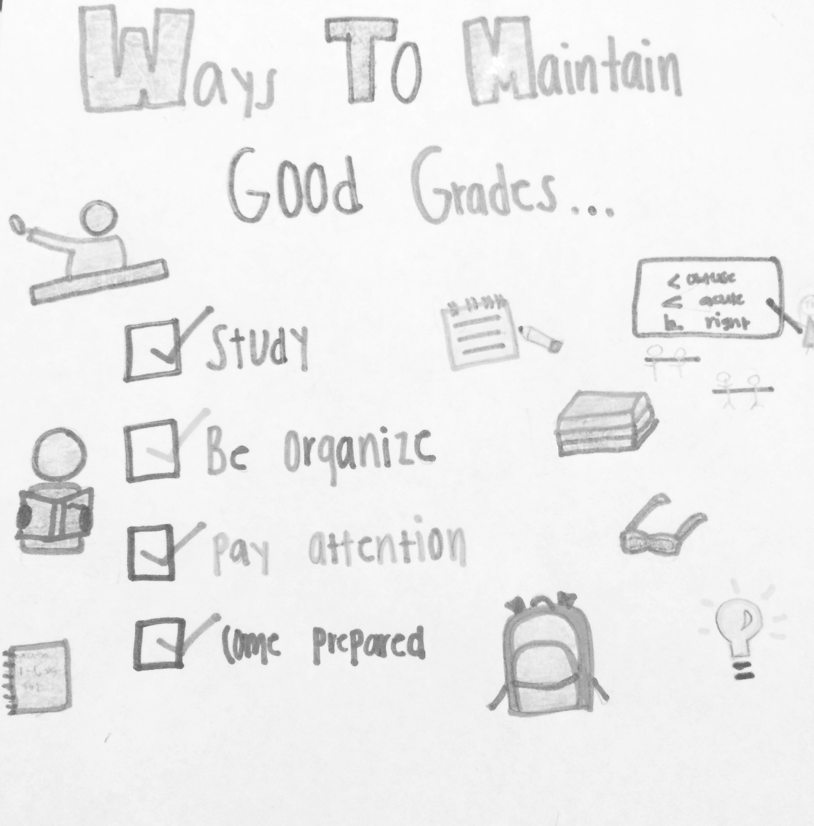

Final Grades will be calculated using the North Carolina format as follows:
1st quarter 40% 2nd quarter 40% EOC 20%

Grades will follow the North Carolina Grading Scale:
100-90 A 89-80 B 79-70 C 69-60 D 59 and Below F

30% of Quarter Grade | 70% of Quarter Grade
Informal assessments must be linked to specific objectives and include a variety of assignments such as warm-ups, notebook checks, quizzes, group work, in-class tasks, class participation, etc. | Formal assessments must be linked to specific objectives and include a variety of assignments such as tests, comprehensive writing assignments, projects, etc.

PBIS Behavior Expectations/Policies

 | Classroom
H  Honor | *Do your own work.  *Follow Cell phone policy.  *Be courteous to everyone.
D  Duty | *Arrive on time and prepared.  *Complete assignments on time.  *Be accountable for your own learning.  *Follow all procedures for entering and exiting the room.
U  Unity | *Work well with other students.  *Work together to maintain a clean, organized environment.  *Follow teachers’ directions.
B  Belief | You can be successful.


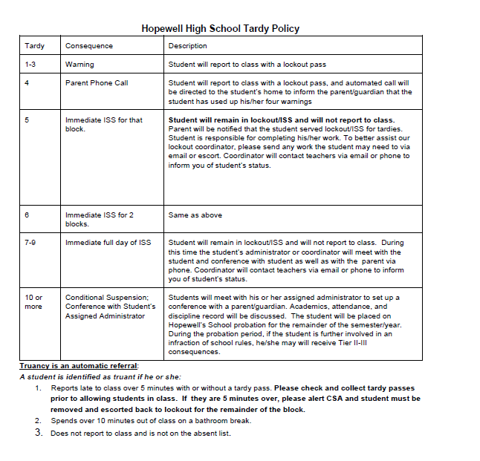



Ms. Urbina’s Classroom Policies:

Mandatory Supplies:
-pencils/pens
-3 ring binder (2 inch or larger) with loose leaf paper
- home access to the internet is desired and highly encouraged

Classroom rules for conduct:
- Students will come to class prepared to learn each day just as the teacher will be prepared to teach each day. As you enter class, take your seat, get out the necessary supplies and be ready to begin class.
- Discussion is encouraged during group activities and other activities where students have time available, but not during lectures, note taking, when instructions are being given, or when someone else is talking (peer or instructor).
- No swearing, hitting, kicking, or any other physical contact with the instructor or other students and/or visitors to the classroom.
- Be in your assigned seat when the final bell rings. Once you report to class do not stand outside the door.
- A student must obtain permission before leaving the room for any reason. If you are gone longer than you should be, or are found in a location other than permitted you will lose these privileges indefinitely. No students will be allowed to leave the class during the first or last 15 minutes of the period. Students will be allowed only two passes out of class a week so they should be used wisely.
- Lab safety will always be maintained. Any student who violates lab safety rules will be removed from the lab and given an alternate assignment to complete. Please wait for permission before touching any lab supplies, etc.
- There can be no food, drink, make-up, toys, hairbrushes, etc. out during class time.
- Students will maintain an organized notebook. It is your responsibility to make sure you have all of your work and notes.
- All work, progress reports, etc. should be turned into the pink basket. It is the student’s responsibility to turn all work into this basket without teacher prompting.
- No name papers will be placed in a folder on the bulletin board. It is the student’s responsibility to check this folder for their work. At the end of the quarter papers in the folder will be thrown away.

Failure to follow these rules will result in consequences based on the PBIS plan and SIRS plan.

Teacher Contact:

I will be using a program called Remind to remind students and parents about upcoming deadlines. It is an online texting service set up for teachers which both students and parents can sign up for to get reminders on upcoming project and test deadlines. It is completely safe and anonymous. I will not be given student or parent phone numbers by you signing up.
If you would like to sign up please choose the class your child is in and text the code next to it to the following number 81010.

Period 3A: @urbina3a
Period 3B: @urbina3b

Keeping up with your grades

The best way to keep up with student grades is through Power School, the online gradebook that NC State has adopted. The gradebook will let you know about your student’s current quarter average as well as the grades made on individual assignments. Please keep up with the grades and e-mail me about any concerns you may have.

Cell Phone/Electronics Policy
Research has proven that the use of cell phones in the classroom results in a drop in students’ grades. Ms. Urbina has a class set of Chrome books which means all work needing electronic devices will be developed on the chrome books and makes the use of cell phones unnecessary in class.

I will follow the school stoplight policy: instruction, labs, and readings on red with independent work on green. Green denotes a time to listen to music ONLY not for texting, snapchatting, videos, games, etc. As a Cambridge student I consider you responsible enough to handle your cell phone in a respectful and beneficial manner. However, if I notice that they are becoming a problem I will step in and institute a more stringent cell phone policy. Let’s not have that happen please!


